**SMART TURBIDITY DETECTION SYSTEM WITH AUTOMATED VALVE SHUT-OFF FOR BAUNGON WATER SUPPLY SYSTEM**

**BACARRO, DAVID JOSIAH A,**

**ECHEM, IZAKAHR O.**

**MAGSUCI, JAMIL B.**

**NAVAREZ, JERICA L.**

**A RESEARCH PROJECT**

Submitted in Partial Fulfillment

of the Requirement for IT321:

CAPSTONE Project and Research 1

Bachelor of Science in Information Technology

Department of Information Technology

College of Information Technology and Computing

University of Science and Technology of Southern Philippines

Cagayan de Oro City, 9000 Philippines

January 2023

|  |  |
| --- | --- |
| **APPROVAL SHEET** | |
| This Thesis entitled: **SMART TURBIDITY DETECTION SYSTEM WITH AUTOMATED VALVE SHUT-OFF FOR BAUNGON WATER SUPPLY SYSTEM**_  prepared and submitted by **IZAKAHR O. ECHEM, JAMIL B. MAGSUCI, DAVID JOSIAH A BACARRO and JERICA L. NAVAREZ** in partial fulfillment of the requirements for the degree **BACHELOR OF SCIENCE IN INFORMATION TECHNOLOGY** has been examined and approved. | |
|  | |
|  | **GERALDINE A. BLANCO** |
|  | Adviser |
|  |  |
|  |  |
|  | |
| PANEL OF EXAMINERS | |
| Approved by the committee on Oral Examination with a grade of PASSED. | |
| **JOCELYN B. BARBOSA, Ph.D.** | |
| Chair | |
|  |  |
| **ARLENE A. BALDELOVAR, MA Ed, MIT** | **Engr. JAY NOEL N. ROJO, MSIT** |
| Member | Member |
|  |  |
|  |  |
| Approved and accepted in partial fulfillment of the requirements for the degree  **BACHELOR OF SCIENCE IN INFORMATION TECHNOLOGY** | |
|  |  |
|  |  |
|  |  |
| Approved: |  |
|  |  |
| **LOVE JHOYE M. RABOY, MIT** |  |
| Dean, CITC |  |
|  |  |
| **JANUARY 30, 2023_** |  |
| Date of Final Defense |  |

**ABSTRACT**

The water supply in Baungon, Bukidnon is prone to issues such as rain and erosion, which can lead to excessive turbidity or cloudiness in the drinking water. This not only affects the appearance of the water, but also poses potential health risks. The personnel at the Baungon Water Supply System Office have reported that the manual method of turning valves on and off at the water treatment facility is causing this excessive turbidity. They also stated that they are unable to continuously monitor the water turbidity or the operation of the valves due to a lack of constant supervision. In order to address this problem, a Smart Water Turbidity Detection System with Automated Valve Shut-off device has been proposed. This system would use machine learning techniques to detect water turbidity and automatically shut off the main valve of the water supply system to minimize or avoid high water turbidity in households. The goal is to benefit both the employees of the water district and the residents of Baungon. The results of the study on this system showed that it is user-friendly, provides clear error messages, can detect dirty water and shut off the valve automatically, and can also be controlled manually through a web application.

**ACKNOWLEDGEMENT**

The completion of this research paper entitled "SMART TURBIDITY DETECTION SYSTEM WITH AUTOMATED VALVE SHUT-OFF FOR BAUNGON WATER SUPPLY SYSTEM" would not have been possible without the support and guidance of several individuals and institutions. We would like to express our sincere gratitude to the following:

First and foremost, we would like to extend our heartfelt thanks to our Chairman, JOCELYN B. BARBOSA, Ph.D, for her invaluable guidance, insightful comments, and unwavering support throughout the research process. Her expertise and dedication have been instrumental in the successful completion of this project.

We would also like to extend our appreciation to our Panelist Members, ENGR. JAY NOEL N. ROJO, MSIT, and ARLENE A. BALDELOVAR, MA Ed, MIT, for their valuable contributions and constructive feedback that have significantly improved the quality of our research work.

Our Thesis Adviser, GERALDINE A. BLANCO, deserves special mention for her tireless efforts and constant support in guiding us throughout the research process. Her guidance, encouragement, and expertise have been invaluable to us, and we are grateful for her contributions.

We would also like to express our heartfelt gratitude to the Baungon Water Treatment Plant Faculty and Staff, our client, for their invaluable support and cooperation during the research process. Their assistance in providing us with the necessary resources and information has been crucial to the success of this project.

Lastly, we would like to thank our family and friends for their unwavering support, encouragement, and understanding throughout the research process. Their constant support and encouragement have been our motivation, and we are grateful for their presence in our lives.

Once again, we extend our sincere gratitude to all the individuals and institutions who have contributed to the successful completion of this research project. Thank you all for your unwavering support and guidance.

**TABLE OF CONTENTS**

|  |  |
| --- | --- |
|  | **Page** |
| **TITLE PAGE** | i |
| **APPROVAL SHEET** | ii |
| **ABSTRACT** | iii |
| **ACKNOWLEDGEMENT** | iv |
| **TABLE OF CONTENTS** | vi |
|  |  |
| **CHAPTER** |  |
|  |  |
| **1 INTRODUCTION** |  |
|  |  |
| 1.1 Background of the Study  1.2 Statement of the Problem | 1  4 |
| 1.3 Objectives of the Study | 6 |
| 1.4 Significance of the Study | 6 |
| 1.5 Definition of Terms |  |
| 1.6 Scope and Limitation | 8 |
|  |  |
| **2 REVIEW OF RELATED LITERATURE** | 10 |
|  |  |
| **3 METHODOLOGY** |  |
|  |  |
| 3.1 Research Design | 22 |
| 3.1.1 Machine Learning Module | 28 |
| 3.1.2 System Architecture | 37 |
| 3.1.3 Software Module | 39 |
| 3.1.4 Hardware Module  3.1.5 Network Design and Module  3.2 Development  3.2.1 Software Specification  3.2.2 Hard Specification  3.2.3 Programming environment  3.3 System Testing  3.3.1 System testing procedure and evaluation | 51  55  59  59  61  64  66  66 |
|  |  |
| **4 RESULTS AND DISCUSSION** | 73 |
|  |  |
| 4.1 Graphical User Interface | 73 |
| 4.2 Performance Testing Procedure for ML Module | 82 |
|  |  |
| **5 CONCLUSIONS AND RECOMMENDATIONS** | 91 |
|  |  |
| 5.1 Summary of findings | 91 |
| 5.2 Conclusion  5.3 Recommendations | 92  93 |
|  |  |
| **BIBLIOGRAPHY** | 95 |
|  |  |
| **APPENDIX** | 100 |
|  |  |
|  |  |
|  |  |
|  |  |
|  |  |

**CHAPTER I**

**INTRODUCTION**

**I. Background of the Study**

According to the Oxford dictionary, turbidity primarily refers to the visual aspect of a liquid being opaque due to the presence of mud, dirt, or other particles, which obstructs the clarity of the liquid. Water is a substance composed of the chemical elements’ hydrogen and oxygen and one of the most plentiful and essential of compounds. It is what we use and consume when we work daily. The planet Earth is made up of 71% water and in the human body, it estimates up to 60%. It is clear that humans need water to survive.

Turbidity is the measure of relative clarity of a liquid. It is an optical characteristic of water and is a measurement of the amount of light that is scattered by material in the water when a light is shined through the water sample. (USGS Water Science School, 2018). Excessive turbidity, or cloudiness, in drinking water is both aesthetically unappealing and potentially harmful to one's health. And this is one of the concerns in the Baungon Water Supply System.

Accordingly, the proponents proposed a detection system that uses machine learning as a way to detect if the water is turbid or not. Machine Learning, according to Arthur Samuel, is defined as a "field of study that gives computers the ability to learn without being explicitly programmed" (Samuel, 1959). How the computer learns is through the algorithm and the data it uses. The algorithm then optimally configures itself so that it cannot only produce the desired outcome when presented with the training inputs but can generalize to produce the desired outcome from new, previously unseen data (El Naqa, 2015).

Several studies utilize machine learning techniques to detect water turbidity. One example of this is the study done by Wang et al. (2021) wherein they compare three machine learning models, Artificial Neural Networks (ANN), Genetic Programming (GP), and Support Vector Machine (SVM) to accurately predict the tidally-averaged sea surface turbidity (Wang et al., 2021). Their study has identified that ANN or Artificial Neural Networks works best in terms of performance and the GP (Genetic Programming) provides meaningful predictors. Another study was done by Hafeez et al. (2019) wherein they use satellite data of "surface water" to identify concentrations of suspended solids (SS), chlorophyll-a (Chl-a), and turbidity. They then feed that data to several machine learning techniques which include Artificial Neural Network (ANN), Random Forest (RF), Cubist regression (CB), and Support Vector Regression (SVR). Their results then indicate that the NN-based machine learning approaches perform better and can be used for water quality monitoring with satellite data in optically complex coastal waters (Hafeez et al., 2019).

The location of the main water supply in Baungon is prone to rain and erosion. The people who work in the water district wanted to automate their water control system so th at whenever the water becomes high in turbidity, the main valve of the system will be completely shut off.

With this, the proponents would like to provide a solution that will minimize, if not totally avoid, the high water turbidity that comes into the household of every residence in Baungon. Thus, this gives the proponents the rationale to conduct the research on creating a Smart Water Turbidity Detection System with Automated Valve Shut-off device in Baungon that will benefit both the employees of the water district and residents of

**1.2. Statement of the Problem**

Water Turbidity is relevant in the country since we are experiencing rains but, not all the time that’s the cause. Sources of turbidity can include soil erosion, waste discharge, urban runoff, eroding stream banks, and large numbers of bottom feeding fish, which can stir up sediment, excessive growth of algae, microorganisms and land development.

In drinking water, turbidity can indicate the presence of high bacteria levels, pathogens, or particles that can shelter harmful organisms from disinfection processes therefore, water treatment plants constantly monitor turbidity levels to ensure that the water does not exceed safe levels.

In Baungon, when it starts to rain, or when some land erodes near the water supply from the main source, their water becomes cloudy or muddy. According to USGS (United States Geological Survey), “During a rainstorm, particles from the surrounding land are washed into the river making the water a muddy brown color, indicating water that has higher turbidity values. In addition, during high flows, water velocities are faster and water volumes are higher, which can more easily stir up and suspend material from the streambed, causing high turbidity.”

After an interview from some personnel in Baungon Water Supply System Office, we found out that their water users are experiencing water turbidity in their homes and the reason for that is the manual method of turning on/off of the water valves in the water treatment facility. Somehow, they cannot continuously monitor the turbidness of the water nor the current operation of the valves in the facility because not all the time, there is someone who guards around the area.

GrowthForce stated that “Automation opens the doors to a more efficient, productive, and flexible work model. Automation can not only drive efficient decision making and improve allocation of resources, but also increase employee productivity.” Because human errors are inevitable, implementing automated processes minimizes errors and redundancies, resulting in much more efficient work. For processes that consist of many lower-level administrative tasks, automation can provide significant time and cost savings. Decisions can’t be made without information. Automation puts information at your fingertips so you aren’t making hasty decisions on your gut, and that brings the proponents to the proposed research on Smart Water Turbidity Detection System with Automated Valve Shut-off for Baungon, Bukidnon Water District.

**1.3. Objectives of the Study**

The purpose of this project is to develop a Smart Water Turbidity Detection System with Automated Valve Shut-off which can be used by the local government of Baungon Water Supply System. Specifically, this project aims

1. To design a machine learning based-model that predicts water turbidity.
2. To create a module that sends a data to the application server once the water turbidity has been predicted
3. To evaluate the efficiency of the proposed system in terms of accuracy, functionality, and usability.

**1.4. Significance of the Study**

This study focused on the benefits of the Baungon Water Supply System by helping them in water turbidity detection through the use of Machine learning techniques. The smart water turbidity detection system comprises several modules. The camera is placed on the top of the reservoir to take pictures of the water. The image is then processed by the machine learning algorithm that is locally stored inside the Raspberry Pi. If the algorithm detects that the water is turbid it will then trigger the solenoid (actuators) to turn off the main valve. The GSM module will also send data to the server via GPRS which then be utilized by the web application. This innovation would be helpful for the Baungon Water Supply System and also for the water consumers. Nowadays, Baungon Water Supply System personnel monitor turbidity and control the valves manually. By the use of this system, the Baungon Water Supply System does not have to worry about the water quality and also, the system requires less human interaction. Moreover, the result of the study can be great benefit to the following:

**Baungon Municipal Engineering Office**. This research study may serve as an additional source of information to improve and develop more innovative and high-end devices for the Baungon Water Supply System

**Baungon Water Supply System.** This research study will be beneficial to them as it will help them monitor turbidity.

**Baungon Water Supply System Consumers.** This research study will help to ensure good quality of water is produced every day.

**Students.** The results of this study would provide students useful and reflective insights on different factors that could influence them in pursuing a career path.

**Proponents and Future Proponents**. In this study, the proponents have acquired new skills and knowledge that they can use in their profession. The results of the study may serve as reference materials and guides for future proponents who would like to conduct related studies or subject this study for improvement.

**1.5 Definition of Terms**

1. *Algorithm*: A process or set of rules to be followed in calculations or other problem-solving operations especially by a computer1.
2. *Artificial Intelligence*: The development of computer systems able to perform tasks that normally require human intelligence, such as visual perception, speech recognition, decision-making, and translation between languages.
3. *Circuit*: An interconnection of electrical elements forming a complete path for the flow of current.
4. *Dataset*: A collection of related sets of information that is composed of separate elements but can be manipulated as a unit by a computer.
5. *Deep Learning*: A subset of machine learning in artificial intelligence (AI) that has networks capable of learning unsupervised from data that is unstructured or unlabeled.
6. *FFmpeg*: A free and open-source software project consisting of a vast software suite of libraries and programs for handling video, audio and other multimedia files and streams.
7. *Firmware*: Programming that’s written to a hardware device’s nonvolatile memory.
8. *ISO*: International Organization for Standardization; an independent, non-governmental international organization that develops and publishes standards for various fields and industries.
9. *Machine Learning*: A subset of artificial intelligence that involves the use of algorithms and statistical models to enable systems to improve their performance on a specific task through experience.
10. *Model*: In machine learning, a model is a mathematical representation of a real-world process that is used to make predictions or decisions without being explicitly programmed to perform the task.
11. *PNG*: Portable Network Graphics; a raster-graphics file format that supports lossless data compression.
12. *Raspberry Pi*: A series of small single-board computers developed in the United Kingdom by the Raspberry Pi Foundation to promote teaching of basic computer science in schools and in developing countries.
13. *Server*: A computer or program that manages access to a centralized resource or service in a network.
14. *Solenoid*: An electromechanical device that converts electrical energy into linear mechanical motion.
15. *Tensorflow*: An open-source software library for dataflow and differentiable programming across a range of tasks, developed by Google Brain Team.
16. *Turbidity*: The quality of being cloudy, opaque, or thick with suspended matter.
17. *Valve*: A device that regulates, directs or controls the flow of a fluid by opening, closing or partially obstructing various passageways.

**1.6. Scope and Limitations**

This study focused on the use of a Smart Water Turbidity Detection System with Automated Valve Shut-off for Baungon, Bukidnon Water District.

The system will only work if there is availability of power. In cases wherein there is no power in the area then the auto shut-off valve feature will not work.

The system detects turbidity through the camera sensor. The sensor will fail to identify the water turbidity accurately if there is a blockage to the camera lens. Blockage to the camera lens may be due to a leaf or other foreign objects that may enter the reservoir.

The system also needs network credits to be able to communicate with the client. The network credits or “load” will be used to send data via GPRS to send data to the application server that will be utilized by our web application.

The subjects for this study will limit to the Municipality of Baungon that covers 5 barangay; San Vicente(258), Mabunga(105), Salimbalan(414), Imbatug(888), and Liboran(326) with the total of 1,991 water consumers.

**CHAPTER II**

**REVIEW OF RELATED STUDY AND LITERATURE**

**Foreign Studies**

In the study of Thompson, et.al (2010) entitled “Providing clean-water, keeping water clean: an integrated approach”, every year, millions of people, most of them children in developing countries, die of basic hygiene-related illnesses. Interventions in Hygiene, sanitation and water supply have been shown to control the burden of illness. Universal access to improved water sources and basic sanitation remains elusive, but is an important long-term goal. The extent to which improving drinking water quality at the household level reduces diarrheal disease is a variety of technical and site-specific environmental and demographic factors that require further investigation, characterization, and analysis.

Kruse (2018) stated in his study “Review in water quality sensor” water quality sensors are very important to ensure access to drinking water in cities and communities Countryside settings. It can also be used for environmental management of resources. Extraction industry, industrial and municipal wastewater treatment, military facilities, etc. Not just agriculture. Automated remote and real-time monitoring of mine tailing spills ponds, industrial process water, industrial and urban wastewater, agricultural irrigation and drainage can lead to immediate notification and prompt corrective action Measures that can avoid major environmental damage.

Boyd (2019) in his book “Water quality: an introduction” as human population has grown, the necessity for producing goods and services necessary or desired by the population has increased, resulting in greater water use and water population. Water quality has increased in importance, because the quality of water often cannot be assessed independently of its quality. Water quality is a critical consideration in domestic, agricultural, and industrial water supply, and the health of ecosystems. Professionals in many disciplines should understand the factors controlling concentrations of water quality variables as well as the effects of water quality on ecosystems and humans. Efficient management of water resources requires the application of knowledge about water quality.

Megersa Olumana Dinka(2017) stated in her study “Safe Drinking Water: Concepts, Benefits, Principles and Standards” that clean and safe drinking water must be offered to a variety of users. There is no commonly recognized definition of "safe drinking water," which is defined as water that poses no major health risk over the course of a lifetime of use. Drinking water that is pure, wholesome, healthy, and potable must be given. Safe water is not always pure; it may include contaminants. It contains traces of magnesium, calcium, carbonates, bicarbonates, and other salts.

**Local Studies**

One study, conducted by proponents at the University of the Philippines Diliman(2014) entitled “Development of a Low-Cost Turbidity Sensor Using Photodiode and LED”, developed a low-cost turbidity sensor using a photodiode and an LED as the light source. The device was tested in a range of water samples and was found to be effective for the measurement of turbidity, with good accuracy and precision.

Another study, conducted by proponents at the University of Santo Tomas(2016) entitled “Design and Development of a Portable Turbidity Meter”, they developed a portable turbidity meter using an LED light source and a phototransistor detector. The device was tested in a range of water samples and was found to be accurate and reliable, with a good degree of repeatability.

**Water Turbidity Detection System**

Vaishnavi V. Daigavane and Dr. M.A Gaikwad(2021) discussed in their study “Water Quality Monitoring System Based on IOT '' that water pollution is one of the biggest fears for green globalization. In order to ensure the safe supply of the drinking water the quality needs to be monitored in real time. In their paper,they presented a design and development of a low cost system for real time monitoring of the water quality in IOT(internet of things).The system consists of several sensors used to measure physical and chemical parameters of the water. The parameters such as temperature, PH, turbidity, flow sensor of the water can be measured. The measured values from the sensors can be processed by the core controller. The Arduino model can be used as a core controller. Finally, the sensor data can be viewed on the internet using the WI-FI system.

Theofanis P. Lambrou et al stated in their study entitled “A Nephelometric Turbidity System for Monitoring Residential Drinking Water Quality '' the study expounded that the development of a turbidity system for monitoring drinking water quality in households is presented. Its operation is based on the principle that the intensity of the light scattered by the suspended matter is proportional to its concentration. Unlike the commercially available turbidity meters, which are relatively expensive and bulky, the proposed device is small-sized, low power, lightweight, easy to use and inexpensive. Laboratory tests of the device have yielded satisfactory repeatability and precision. This sensor can be used as a part of a low-cost sensor network consisting of different types of sensors (pH, temperature, chloride, etc.) to provide water quality information to consumers. Fusing on-line multi sensor measurements, the system can provide useful information regarding hazardous agents and waterborne pathogens contaminants of household drinking water, raising awareness and encouraging better water-handling.

**Machine learning**

The field of machine learning has been defined in several ways in literature.Arthur Samuel defined machine learning as a “Field of study that gives computers the ability to learn without being explicitly programmed” (Samuel, 1959). Tom Mitchell, a renowned computer scientist and machine learning, stated that “Machine Learning is the study of computer algorithms that improve automatically through experience”(Mitchell, 1997).Ethem Alpaydinin his textbook, defined machine learning as the field of “Programming computers to optimize a performance criterion using example data or past experience” (Alpaydin, 2014).These definitions share a common idea of teaching computers to perform complicated task other than standard number-crunching by repeatedly learning their surroundings through examples.

The origins of machine learning may be traced back to the seventeenth century when Pascal and Leibniz developed devices that could mimic the human capacity to add and subtract (Ifrah, 2001).In recent history, Arthur Samuel of IBM demonstrated that computers could be programmed to learn to play checkers. More recently, distributed multi-layered learning algorithms have emerged under the notion of deep learning (Hinton, 2007).

According to the study of Ayodele (2010), which is entitled “Types of machine learning algorithms”, he discussed that machine learning algorithms are organized according to the desired outcome of the algorithm. Common algorithm types include Supervised learning, Unsupervised learning, Semi-supervised learning, Reinforcement learning, Transduction, and Learning to learn. In Supervised learning, the algorithm generates a function that maps inputs to desired outputs. Supervised learning is common in classification problems like digit recognition. On the other hand, the goal of unsupervised learning is to have the computer learn how to do something without telling how to do it. There are two approaches for unsupervised learning. The first one is teaching the computer not by giving the correct answer but using some sort of reward system to indicate success. The second type of unsupervised learning is called clustering. The goal of this type of learning is to maximize a utility function, but simply to find similarities in the training data. Another type of algorithm is the Semi-supervised learning, which is a combination of both labeled and unlabeled examples to generate appropriate classifiers. Reinforcement learning is when a machine or an agent interacts with its environment, performs actions, and learns by a trial-and-error method. Transduction is also a type of machine learning algorithm that is similar to supervised learning but does not explicitly construct a function: instead, tries to predict new outputs based on training inputs, training outputs, and new inputs. Learning to learn is also a type of machine learning algorithm that learns its own inductive based on previous experience.

**Deep Learning**

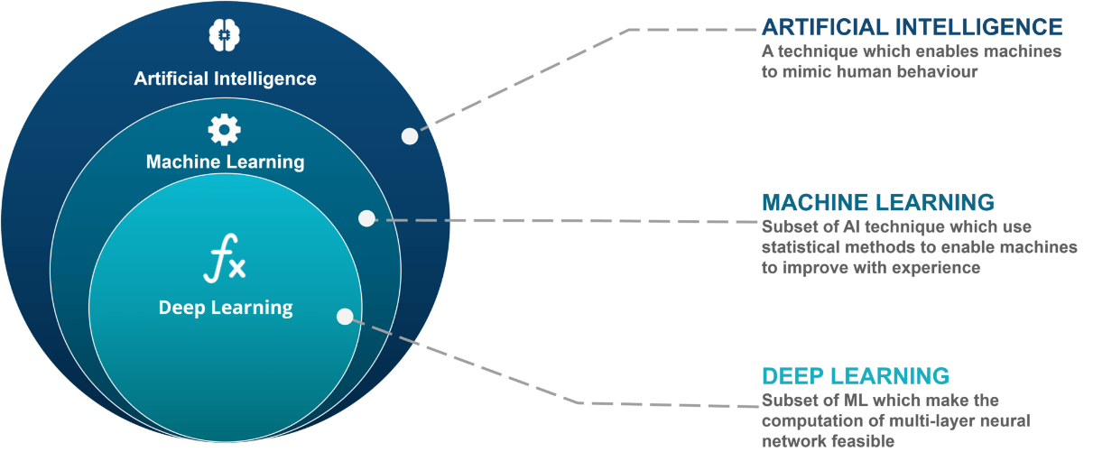Figure 1 shows the difference between artificial intelligence, machine learning and deep learning. Artificial intelligence is the broader term that encompasses machine learning and deep learning. AI is a technique that allows machines to mimic human behavior. Machine learning is a subset of AI, which allows machines to learn and predict based on experience or data being fed to it. Deep learning on the other hand is a subset of machine learning. It represents the world as a nested hierarchy of concepts or abstraction.

Figure 1. Artificial Intelligence Hierarchy

The key difference between machine learning and deep learning lies in the fact that Deep Learning automatically finds the features which are important for classification, compared to Machine Learning where we had to manually give the features as shown in Figure 2.

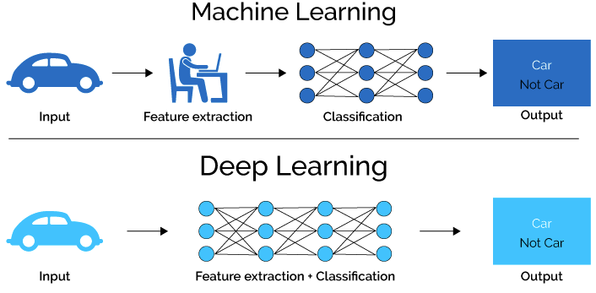Figure 2. Machine Learning vs Deep Learning

**Tensorflow**

TensorFlow is an open-source software library created by Google Brain Team that is used for numerical computation and machine learning. It was designed to facilitate the creation and training of machine learning models, particularly deep neural networks. TensorFlow's main feature is the ability to create and manipulate data flow graphs, which represent the mathematical operations that are applied to the data as it moves through the neural network. TensorFlow can be used with several programming languages, including Python, C++, and Java, making it a versatile tool for machine learning development (Dumoulin & Visin, 2016).

The core of TensorFlow is its computational graph, which consists of nodes and edges that represent the mathematical operations and data flow between them. Each node in the graph performs a specific operation on the data, such as addition, multiplication, or convolution. The edges represent the data that is passed between the nodes. By constructing a graph of operations, TensorFlow can optimize the computations to improve the efficiency of the neural network. TensorFlow also includes several high-level APIs for constructing and training neural networks, making it accessible to researchers and developers with varying levels of experience (Abadi et al., 2016).

**Teachable Machines**

Teachable Machine is a web based tool for creating machine learning models. It is intended for students, educators, and anyone who has no background in machine learning. The way this service works is that the user trains a computer to recognize images, sounds and poses without writing any machine learning code. After training, a model is then generated to be used for any kind of project that involves machine learning. Several studies have shown the effectiveness of this web based platform as a reliable tool for machine learning projects. One study done by Forchhammer et al., 2022 titled “Development of an Image Analysis-Based Prognosis Score Using Google’s Teachable Machine in Melanoma” proves that prognostic estimate to conventional melanoma is possible at a cellular level through the use of Google’s Teachable Machine.

D. Agustian et al(2021) stated in their study entitled “Implementation of Machine Learning Using Google's Teachable Machine Based on Android” the study expounded that Machine Learning Implementation Using Google's Teachable Machine on Android Google's Teachable Machine can generate a machine learning model with a test accuracy rate of up to 100%. The level of accuracy can be reduced based on the lighting at the detection site.

Overall machine learning uses computer algorithms that can learn from their surrounding environment to optimize the solution for a given task. With the help of Machine Learning, laborious tasks such as detecting the water turbidity can now be automated. Tensorflow and Teachable Machines provides individuals without any machine learning background to implement and harness the benefits that the machine learning provides by gathering data sets and training them in the cloud.

**CHAPTER III**

**RESEARCH METHODOLOGY**

In this chapter, the proponents will discuss the research methodologies for designing, developing, implementing, and testing that are going to be used for the development of the project. It includes the research design, development specifications that were carried out by the proponents in the development of this study.

**3.1 Research Design**

This section presents the broad framework of the project that states the total pattern of conducting research study and on how this project was carried out. The developers conducted several experiments such as testing the codes for each subsystem and then integrating it to form a new system. They also conducted several tests for the whole system after the integration.

For the research method, the proponents use the agile methodology. Agile methodology is mostly utilized in software development, where needs and solutions emerge from the collaboration of self-organizing and cross-functional teams as well as their clients. It places a premium on adaptability and flexibility. Agile focuses on enabling teams to deliver in manageable increments in order to give improved responsiveness to changing needs. After developing the system, it will go through several tests and allow the developers to go back to the previous steps in order to meet the requirements for the system as show in Figure 3.

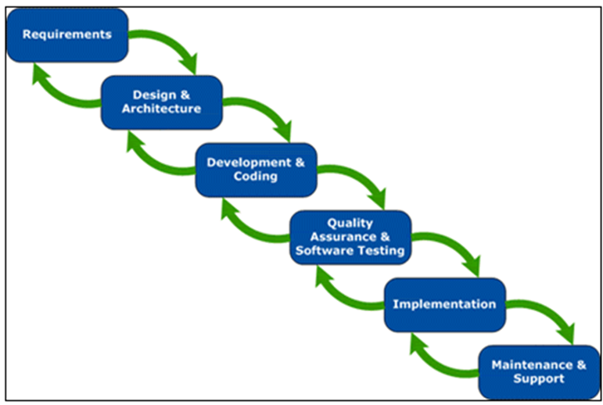

Figure 3. Steps of Agile Methodology

**Requirements Gathering and Analysis** - In this phase, the proponents collected all relevant information regarding the Baungon Water supply system, specifically focusing on the issue of turbid water supply and the challenges of monitoring it. The proponents began by examining the water monitoring problems at the Baungon water supply system. Subsequently, they interviewed the head of the Baungon water supply office, who provided information on the advantages and benefits of automated valve shut-off. The proponents then obtained the necessary knowledge on the hardware, software, and testing instruments to be used in the study, as well as the statistical tools to be employed for evaluating the device's data.

To help organize the activities and ensure that the project stays on track, the proponents developed a Gantt chart that outlines the timeline for each phase of the research project, including the requirements gathering and analysis phase. The Gantt chart, which is attached to the appendix of this paper, provides a visual representation of the project timeline, including the start and end dates of each activity, as well as the interdependencies between the different tasks. The Gantt chart serves as a useful tool for project management, allowing the proponents to track progress, identify potential delays, and adjust the project timeline as necessary.

**Design and Architecture** - In this phase, the device was created using information gathered throughout the requirement analysis and planning phase. Following the collection of data and the completion of interviews and surveys, proponents begin to consider what software will be used for developing the system so that the user will be able to use the device with ease and satisfaction. Also, proponents consider what hardware components and materials will fit the system then what libraries are needed for the program. Also, proponents conduct experiments to know if all the sensors are working accordingly. To test the components functionality of the device, the proponents tested each subsystem of the machine several times before integrating it. The proponents also did trial and error methods during the testing of the subsystems to make sure that all the components function properly before integrating them all to a one system.

**Development and coding** - After the proponents gathered data and designed a device, the proponents began working on the project's development, integrated and applied the appropriate components in the device's construction. In addition, the developers utilized system-required software. The proponents combined all the program source code to create one system for all of the hardware components employed in the device. The proponents began the development of the prototype by configuring the main computer board. The next step is the wiring process. All the wires must be placed where the components will be placed and long enough to reach the other end. After fabricating the wiring, it will be connected to the intended components of the system. The proponents made sure that all the components were connected firmly to its proper wiring. The proponents also lend attention to the connections between camera, GSM module, Solenoid valve and Raspberry pi to implement the developed system. After generating the program for all the sensors in the device and uploading the program code in Raspberry PI.

**Quality Assurance and Software Testing** - The next step in agile methodology is quality assurance and software testing, where the developed software is tested to ensure that it meets the required quality standards. In our study, this involves testing the IoT device to ensure that it can accurately detect the color of the water, testing the automated valve shut-off system to ensure that it works as intended, and testing the web application to ensure that it can effectively monitor the water supply system.. It was unavoidable that one or two of the components would stop working following the installation. As a result, troubleshooting of each component was carried out. From the wiring to the correct arrangement of pins from the components to the Raspberry Pi to the testing of each component using the Turbiditech web application for monitoring, everything is covered. Different locations and sim cards were also used to test GSM notifications.

**Implementation** - This stage is for the study's final implementation. Once tested and developed, the system is ready to use and can be integrated or installed as a well-functioning device. The proponents will place the device Baungon Bukidnon to test the GSM module connectivity. The circuit board, which included all of the hardware components and the wiring connections was put inside the control box at the side of the device. Power supply came from 220v AC with a USB C charger brick with 5v 2 amps output installed inside the device. The camera sensor was placed inside the device. The solenoid valves were checked several times to ensure its functionality. The system device for the Smart turbidity detection with automated valve shut off is finally working after several tests.

For the assessment of the project, the proponents approached the Baungon water supply system office head and surveyed some BWSS employees about the experiences, effectiveness, and the functionality by using the device in order to evaluate its functionality.

**Maintenance and Support** - In the Maintenance and Support phase of the Agile methodology, several activities are required to ensure the SMART turbidity detection system with automated valve shut-off for the Baungon Water Supply System is functioning properly. For example, regular testing of the system components, such as the camera and automated valve, should be conducted to ensure they are functioning as intended. Additionally, software updates may be necessary to address any bugs or issues, while regular maintenance on hardware components, such as cleaning the camera lens or replacing a valve, may be required to keep the system running smoothly. Furthermore, user support, such as providing documentation and training on how to use the system, may be necessary to ensure the system is being used properly. Data management is also important to ensure that water quality data is collected, stored, and analyzed effectively. Finally, upgrades and enhancements may be necessary as the system is used and tested, such as adding new features to improve functionality or addressing any issues that arise. These activities will help to ensure that the system is running smoothly, and that any issues or concerns are addressed in a timely manner.

**3.1.1 Machine Learning Module**

1. **Machine Learning Module Flowchart**

To create a machine learning model, the first step is to start by defining the problem you want to solve. Once you have a clear understanding of the problem, the next step is to collect data that is relevant and sufficient to train your model. After collecting the data, you will need to perform data analysis to understand the structure and characteristics of the data. Once the data analysis is complete, the data should be split into training and testing datasets to ensure that the model is not overfitting to the training data. The next step is to train the model using the training dataset, and then test and evaluate the model using the testing dataset. This process will help to ensure that the model is accurately predicting the outcome and is ready for deployment as shown in Figure 4

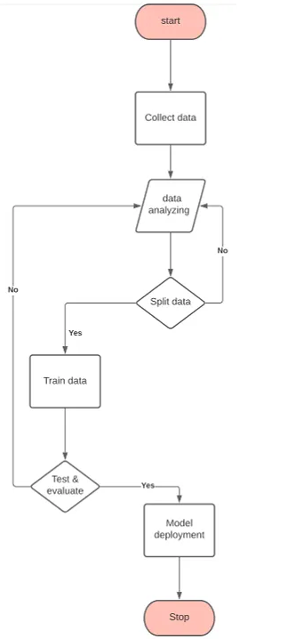

Figure 4. Machine Learning Module Flowchart

1. **Machine Learning Method / Algorithm**

The system that the researcher is building utilizes the Teachable Machine service provided by Google. As mentioned earlier, Teachable Machine is a web-based tool for creating machine learning models. To create a machine learning model that classifies whether a water is clean or dirty is to gather a significant amount of data to train the model. These data sets are images of clean and dirty water that were collected online and from the location of where the study is being conducted. Once data collection is done the images are then uploaded to Teachable Machine’s website. After uploading the images, the next step is training the model. Teachable Machines provides customization when it comes to training the data sets. As shown in Figure 5, it provides the ability to control the *Epoch*, *Batch Size* and the *Learning Rate*. Epoch is the number of times each sample in the training dataset has fed through the training model at least once. For example, if the value of the Epoch is 50 then the entire training dataset is fed through the training model at least 50 times. A batch is a set of samples used in one iteration. For example if there are 80 images and the value of the batch size is set to 16 then there will be 5 batches (80 / 16 = 5). Once all 5 batches are fed to the model, exactly one epoch will be complete

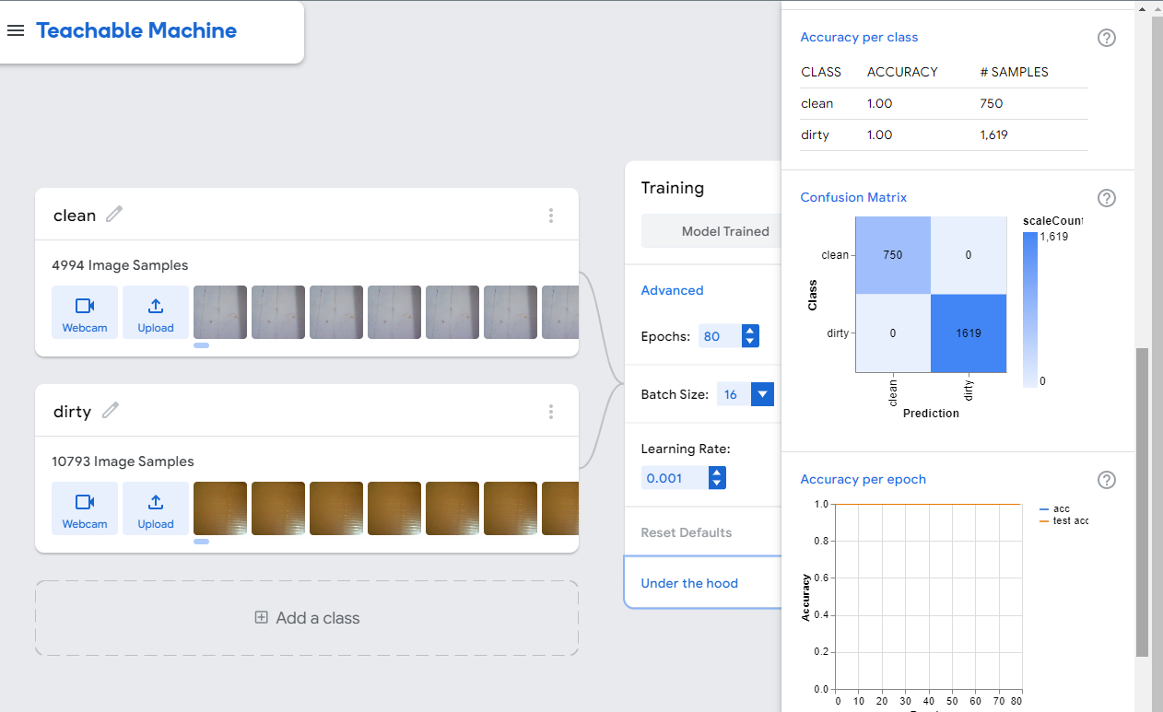

Figure 5. Teachable Machine Customization Parameters

1. **Datasets**

In order to produce an accurate model for our Smart Water Turbidity System ample amount of reliable data should be gathered. The data set the researcher will be using are video clips of clean and dirty water taken from the plastic tub container. A screenshot of the video samples are show in Figure 6. The researcher gather first clean water video samples by pouring in clean water to the container. To have varying data samples, the container is placed in different locations with different light conditions. The researcher then records a one minute video each time the container is move to a different location. The same process also applies for getting dirty water samples. The only difference is that we gather more dirty water video samples than clean water images to have more bias on dirty water results. The videos are then converted into images using a command line tool called ffmpeg as shown in Figure 7. Ffmpeg extracts all the frames from the video and converts them into .PNG format. The researcher then created folders named “clean water” and “dirty water”. Images are then placed on each folder according to their classification. A total of 4994 clean water images (Figure 8) and 10,793 dirty water images (Figure 9) were gathered which has a total of 15787 images.

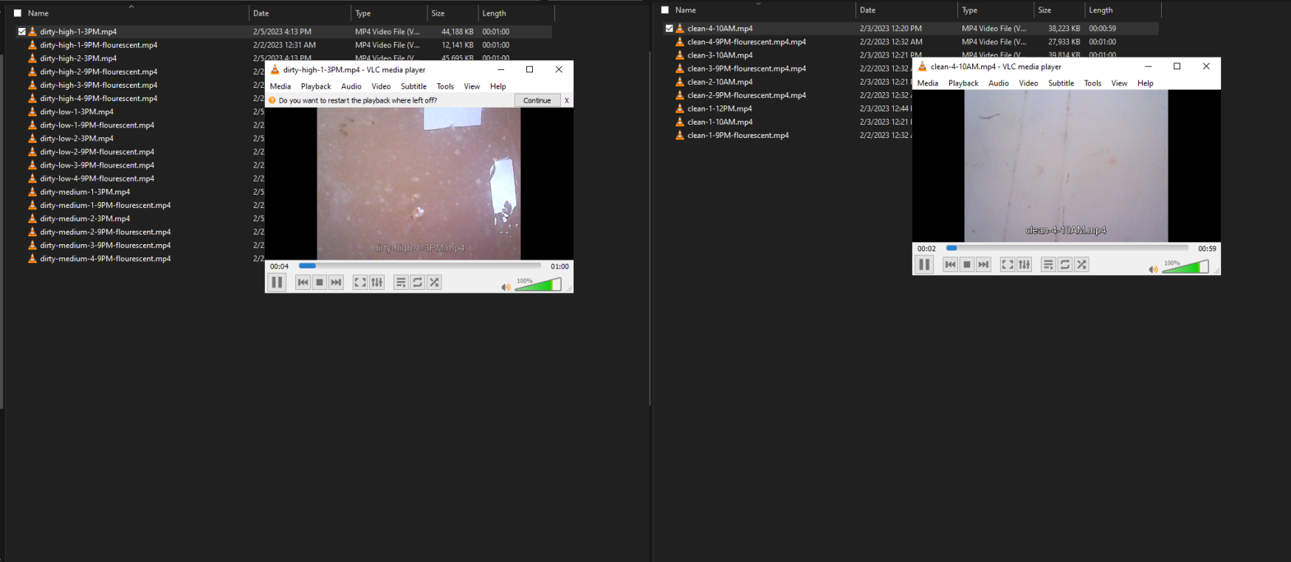

Figure 6. Clean and Dirty video samples

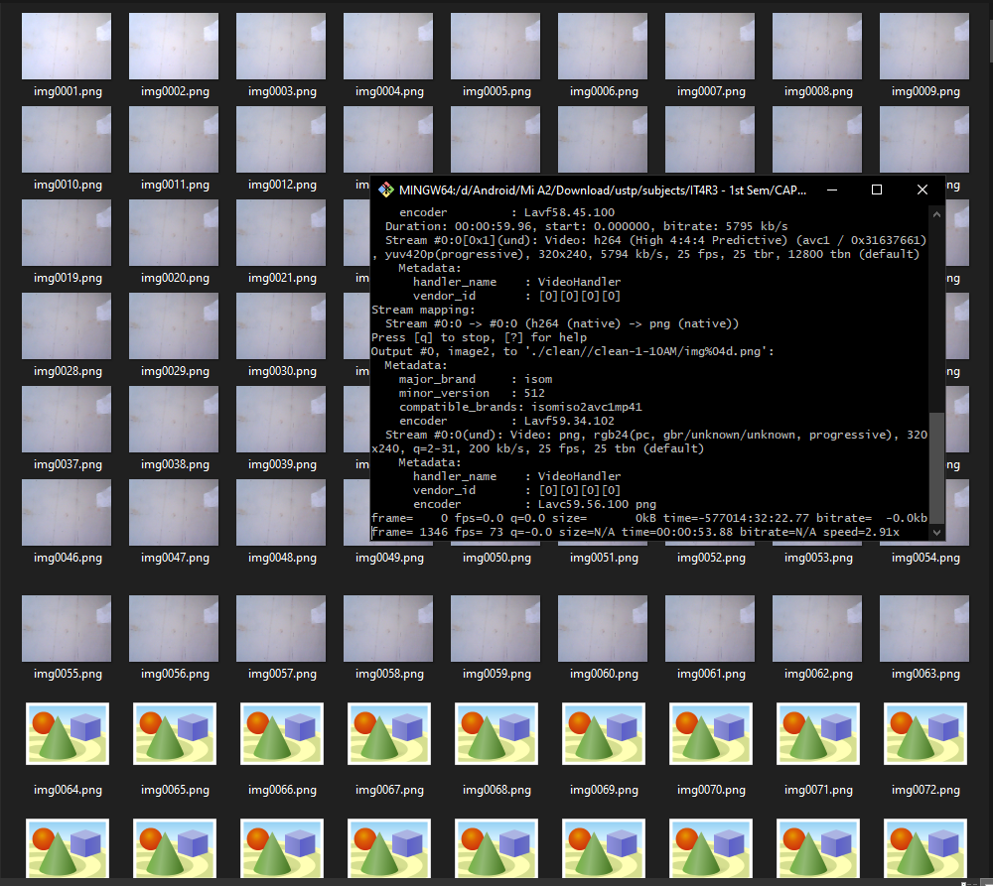

Figure 7. Videos are then converted into images using Ffmpeg

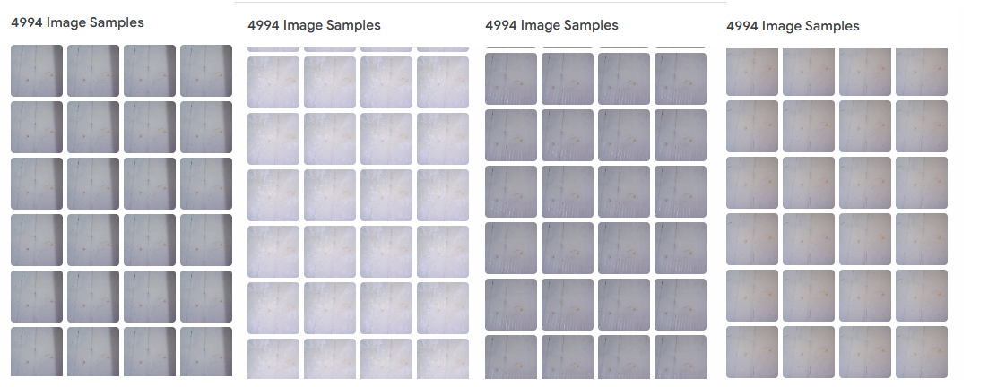Figure 8. Sample clean water images

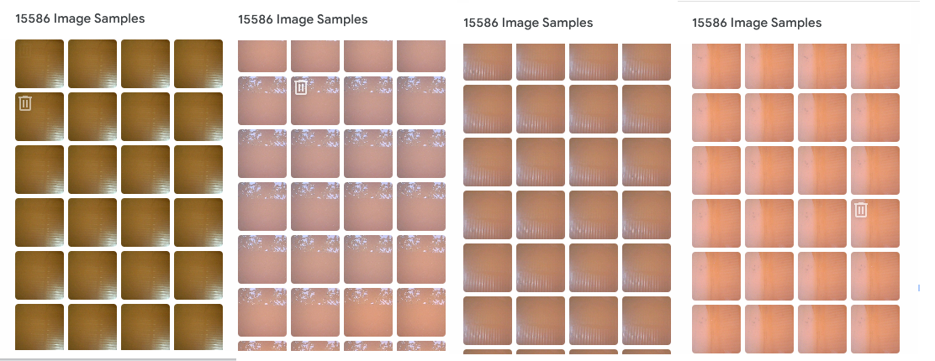Figure 9. Sample dirty water images

**3.1.2 System Architecture**

Figure 10 shows the conceptual model of our system. The camera is placed on top of the reservoir to take pictures of the water. The image is then processed by the machine learning algorithm that is locally stored inside the Raspberry Pi. If the algorithm detects that the water is turbid it will then trigger the solenoid valve to shut off. After it is done, the GSM module will send data to the server via GPRS. The data that was sent to the server will then be utilized by our web application

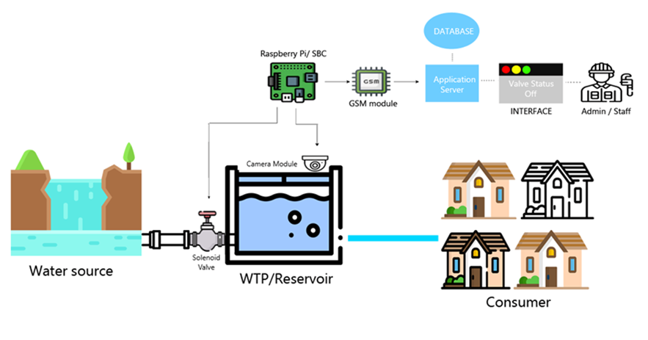

Figure 10. System Architecture ofSmart Turbidity Detection System

**3.1.3 Software Module**

1. **Context Diagram**

Figure 11 shows the context diagram of the Smart Water Turbidity Detection System. The center circle corresponds to the main process of our system. The two rectangular boxes signify external entities to the system. These entities include the device or module itself and the water treatment admin. The role of the device module is to send information about the status of the water through the data it gathered from the sensor. Aside from that it will also consume information from our main process, specifically the valve_status. This information is very important to the module or device to process since this will be the signal to turn ON the valves again after it has been shut-off automatically. The water treatment plant admin is responsible for managing the devices or modules being deployed. The admin also plays a vital role in changing the valve status value because they are one’s deciding whether to turn on the valves or not. The admin is also responsible for adding new devices and registering them to the database.

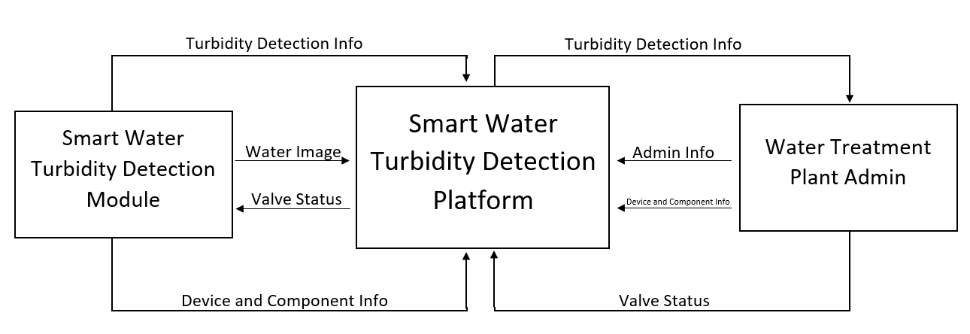

Figure 11. Context Diagram of Smart Water Turbidity Detection System

1. **Data Flow Diagram**

Figure 11 shows the data flow diagram of the system. There are two external entities described in this system. The first is the Water Treatment Plant Admin who is responsible for adding new devices, viewing devices, monitoring the turbidity status and manually turning on the valve base on their own parameters. The second external entity is the Smart Water Turbidity Detection device. The device is responsible for detecting changes in water appearance and automatically controlling the valves once it met the condition being set.

To use the system the water treatment plant admin first login to the system. The login info provided will then be verified and confirmed if the info is present in the tbl_user. Once logged in the admin will either add a new device or check the water turbidity status. To add a new device, all the admin will have to do is input the new device information into the system and it will be stored in the database, specifically the tbl_device and tbl_component table. Aside from adding a new device and component the admin can also view the device and component information through the tbl_device and tbl_component table respectively. The admin can view the turbidity status through the dashboard of the application. From the dashboard the admin can turn ON the valves again after it has been automatically shut-off by the system. Upon turning ON the valves a new valve status is being stored to the Turbidity tbl_turbidityrecord table.

The Smart Water Turbidity Device constantly takes photos of the water and checks if it's clean or not. If it determines that the water is not clean then it will send new turbidity information including the date, time, image of the water and the valve status to the Turbidity tbl_ turbidityrecord table.

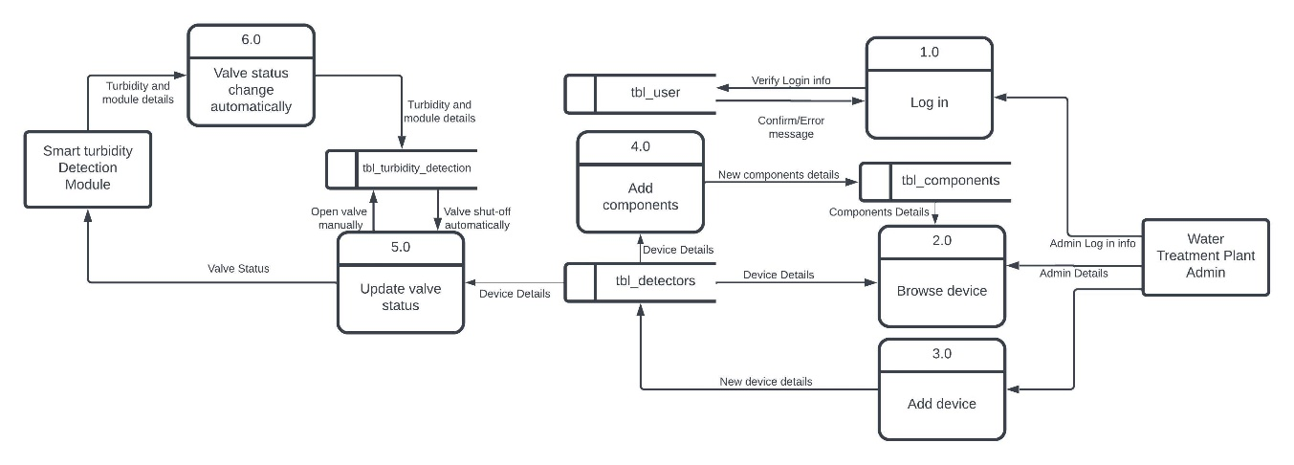Figure 11. Data Flow Diagram of Smart Water Turbidity Detection System

1. **Entity Relationship Diagram**

Figure 12 shows the entity-relationship diagram of the system. The ERD was designed in a way that it can handle more devices for easy scalability of the system. There are four tables namely tbl_user which contain the information of the user who will be using the system. It has a one-to-many relationship with the tbl_device since one user can handle multiple devices but each device can be managed by only one user. This table also contains the location of where the device was installed and who installed it. tbl_device contain information about the device group the system will be using. Each device in the tbl_device corresponds to several components listed on the tbl_component table. The tbl_component contains information specific to the device id on the tbl_device. The tbl_turbidityrecord table contains information about the turbidity status if it's turbid or not. Another information this table contains is if the valve is turned on or off, the water image path, the device_id, and the date and time the device detected changes in water appearance.

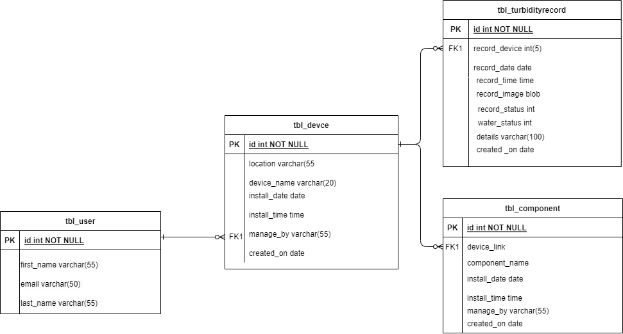

Figure 12. Entity Relationship Diagram of Smart Water Turbidity Detection Web Application

1. **Use Case Diagram**

Figure 13 is the use case diagram of the system. There is only one actor, namely the WTP Admin. The role of WTP Admin includes adding new devices, checking the water turbidity status and updating the valve status. After logging in, the user credentials are verified and after that the WTP Admin can access the main dashboard and all functionalities of the web application.

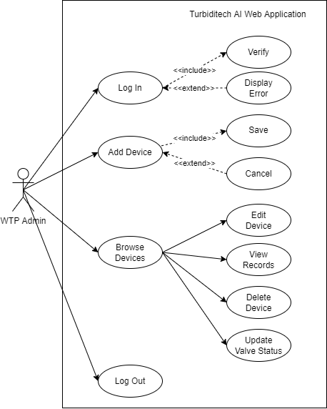

Figure 13. Use Case Diagram of Smart Water Turbidity Detection Web Application

1. **Activity Diagram**

Figure 14 illustrates the activity diagram of the system. As soon as the device is plugged into the outlet, the Raspberry Pi will immediately turn on. The relay and solenoid valve will set their default value to OFF immediately. The device will then execute the activate_gprs.sh script (see Appendix A), which will turn on the GPRS connection. If a GPRS connection is not established, it will try to connect again.

Once the device has successfully connected to the internet, it will execute the activate_script.sh (see Appendix B) next, which contains the main.py script (see Appendix C) that is responsible for detecting whether the water is clean or dirty. The first thing this script will do is check the valve status on the web application. If the status of the valve is OFF, the device will skip the water detection and continuously check the server for changes in the valve status. However, if the device detects that the valve status has been changed on the server, it will perform the water detection. If the water detection result is CLEAN, it will check if both the device water status and the server water status are CLEAN, in that case, no changes will be made to the web application or the valve. But if the device water status is CLEAN and the server water status is DIRTY, it will turn ON the valve and send a picture of the water along with the information that the water is CLEAN and the status of the valve, which is ON. After that, it will then repeat the checking of valve status from the server.

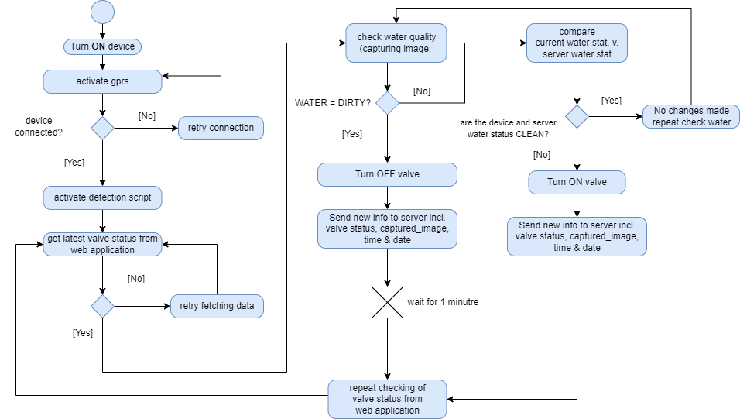

Figure 14. Activity Diagram of Smart Water Turbidity Detection Device

**3.1.4 Hardware Module**

1. **Schematic Diagram**

Figure 15 shows the schematic diagram of the system. The software development is python programming for Raspberry Pi. The system will automatically start as soon as the raspberry pi turns on. After the system has been activated, the camera starts to monitor the turbidity of the water. At critical conditions of turbidity, the system will send data to the website server via General Packet Radio Services facilities inbuilt of GSM module which is packet based wireless communication service that works with the data rate of 56-114 kbps and provides a connection to the internet. Then, the system will automatically shut-off the solenoid valve.

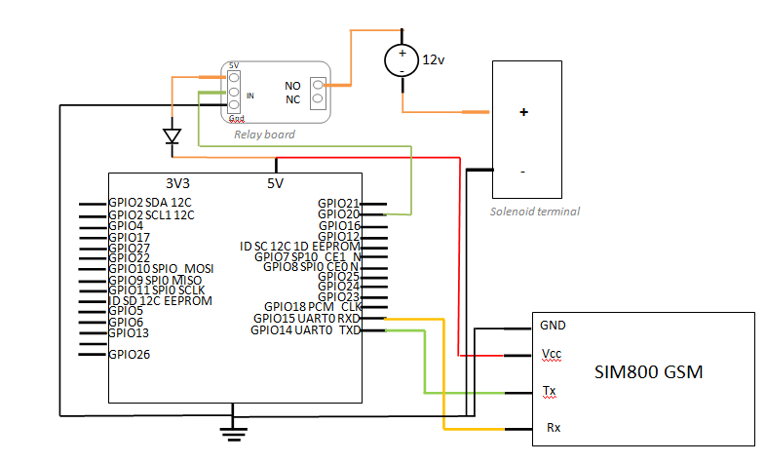

Figure 15. Schematic Diagram of Smart Water Turbidity Detection Device

1. **Circuit Design**

Figure 16 shows the smart turbidity detection system with automated valve shut-off connections; here PI camera is used for capturing images that then the raspberry pi will then use machine learning algorithm to monitor the turbidity of the water through the image captured. The Rx and Tx pins of the GSM module are directly connected to the Rx and Tx pin of the Raspberry Pi respectively. The solenoid valve is powered by a 12 volts battery. 5 volts one channel relay are used for controlling the solenoid valve. And relays are connected to raspberry pi pin number 14 and 16 through a relay driver for controlling the valve.

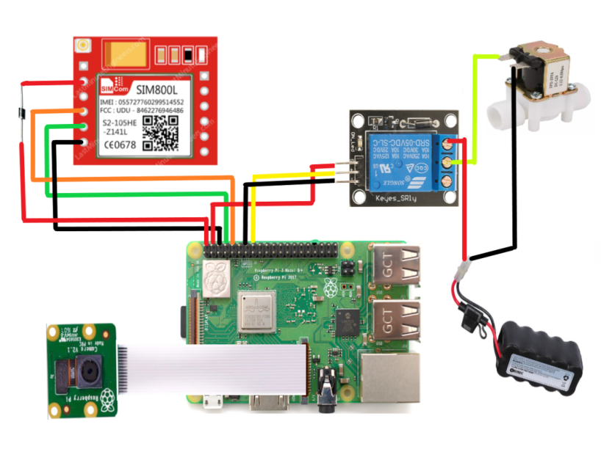

Figure 16. Circuit Design of Smart Water Turbidity Detection Device

**3.1.5 Network Design and Security Module**

1. **Network Topology**

Figure 17 shows the network topology of the GSM module that uses GPRS inbuilt facilities of the GSM module where the system is going to connect to the internet and will send data to the web server and receive commands to open the valve.

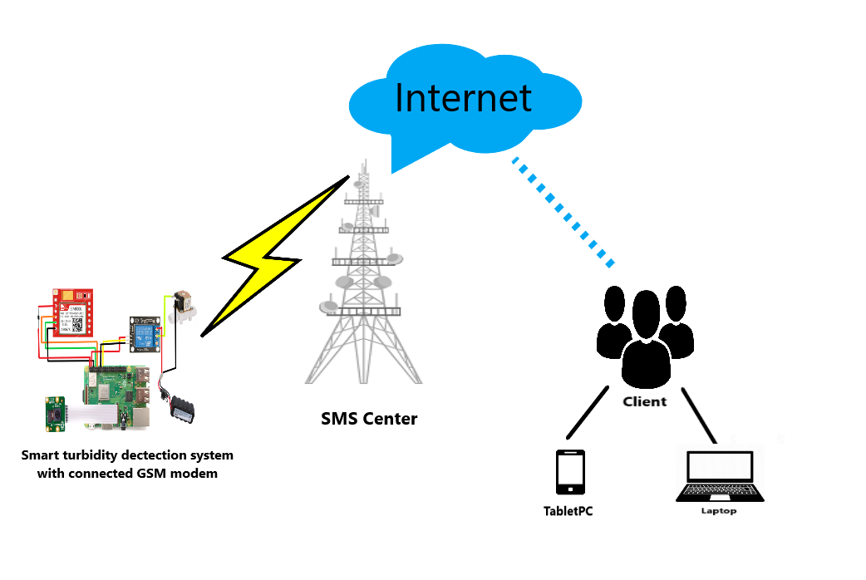

Figure 17. Network Topology of Smart Water Turbidity Detection System

1. **Network Security Model**

Figure 18 illustrates the Iot Security Artichoke. Iot devices must be secured physically from damage, destruction, and tampering. Like an artichoke, physically securing the Iot devices comprises several layers. The first layer is ensuring physical device firmware and interfaces must not be vulnerable. Second layer is to identify component technologies and their features. Third, Iot communication must also be secured. Fourth, Iot sensors and actuator networks must be robust and wireless. Lastly, applying any cryptographic approaches that protect credentials, payloads, and protocol conversations is a must to implement.

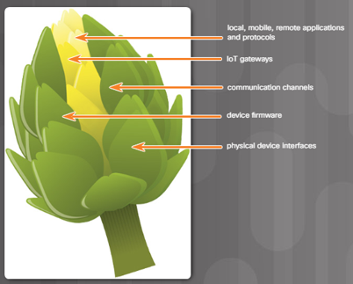

Figure 18. IoT Security Artichoke

Placing the Raspberry Pi device inside a IP65 waterproof plastic enclosure and placing it securely to the site location are just some of the ways the researcher can protect the device from physical threats like the weather and other malicious entities from physically opening the device to gain access to its component parts. Aside from physically securing the device, the researcher also implemented some security hardening on the device internally. The security measures that were implemented include securing the remote access of the device and user accounts, configuring the UFW or the Uncomplicated Firewall rules, and decreasing the attack surface of SSH.

To secure the remote access of the device, the researcher first created a new user account with a unique username and password with sudo permissions enabled. Second step on securing the remote access of the devices was the activation of SSH and restriction of users who can access the SSH. The researcher then edited the sshd_config file located in the /etc/ssh directory to limit the users that are allowed to access this device using SSH. The third step in securing remote access was to delete the default Pi user account which has a username “pi” and a password “raspberry” by typing the command “sudo deluser <name of user>” .

Configuring the Uncomplicated Firewall (UFW) is also an important step in securing the device. UFW provides a more user-friendly framework than the traditional iptables firewall. The UFW needs to be activated and configured to limit dangerous protocols and services, while allowing important connections to be available. Using the commands “sudo ufw deny http”, “sudo ufw allow”, and other various ufw commands the researcher can control who can access and what type of connection are permitted on the device.

Although SSH is already secure there is still room for the attackers to gain access through the device using brute force or user/password attack. To prevent this kind of threat the researcher implemented a limitation on the number of login attempts using the “sudo ufw limit ssh/tcp command”.

**3.2 Development**

**3.2.1 Software Specification**

This are the list of technologies and frameworks that will be used in creating the Smart Water Turbidity Detection System with Auto-shutoff Valve:

**Raspberry Pi OS** – or the ‘Raspbian’, is an Operating System made specifically for the Raspberry Pi. It will be used for the development of the system.

**Python** - is an interpreted, object-oriented, high-level programming language with dynamic semantics and will be used for machine learning and controlling the sensors.

**Django** - is a high-level Python web framework that encourages rapid development and clean, pragmatic design. This will serve as our back-end development framework.

**PostgreSQL** - is a free and open-source relational database management system emphasizing extensibility and SQL compliance.

**Bulma** - a free, open-source framework that provides ready-to-use frontend components that you can easily combine to build responsive web interfaces. It will be used for the front-end development.

**Fly.io -** a platform as a service (PaaS) that enables developers to build, run, and operate applications entirely in the cloud

**3.2.2 Hardware Specification**

**Raspberry Pi** – a single board computer that runs Raspberry Pi OS , but it also provides a set of GPIO (general purpose input/output) pins, allowing you to control electronic components for physical computing and explore the Internet of Things (IoT).

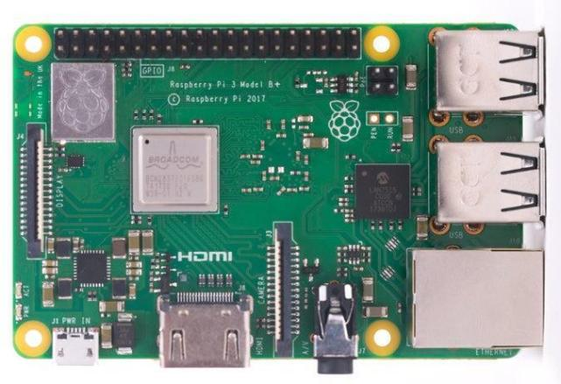

**Camera module** – The Camera Module 2 can be used to take high-definition video, as well as stills photographs

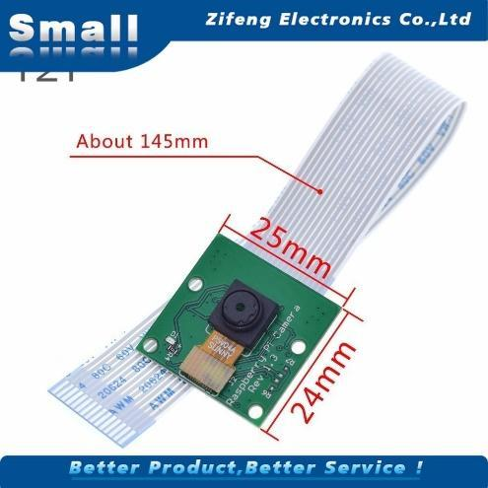

**SIM800L GSM/GPRS Module -** can use this module to accomplish almost anything a normal cell phone can; SMS text messages, Make or receive phone calls, connecting to internet through GPRS, TCP/IP, supports quad-band GSM/GPRS network

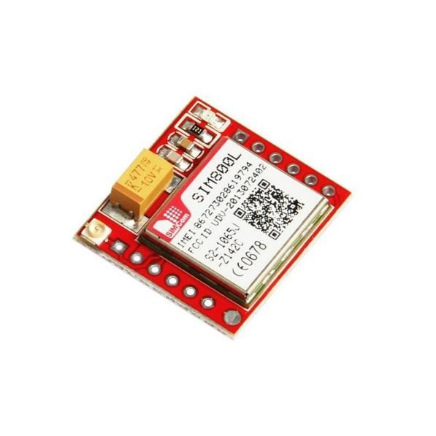

**5V 2A USB C Charger** - This will be the main power source of the device. It is important that the device receives 2 amps or more to power an external device connected to the raspberry pi.

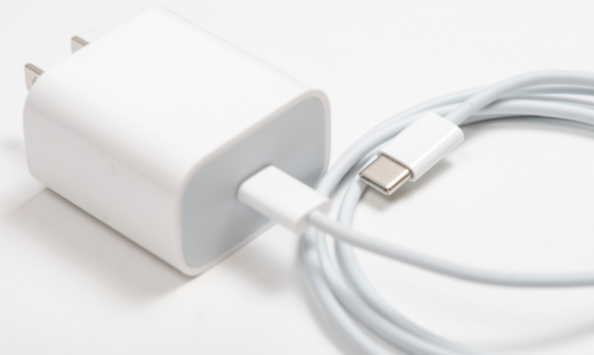

**2PC 9v Battery** - The 9V (nine volt) battery is a rectangular dry cell classified by its 48.5mm x 26.5mm x 17.5mm dimensions and one-sided clasp terminals. They hold mid-range capacities upwards of 1,200mAh



**12V DC Solenoid Valve -** Solenoid valves are used wherever fluid flow has to be controlled automatically. They are being used to an increasing degree in the most varied types of plants and equipment. The variety of different designs which are available enables a valve to be selected to specifically suit the application in question.

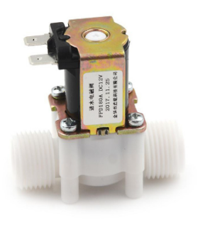

**3.2.3 Programming Environment**

1. **Front End**

**Bulma CSS Framework** is a free, open-source CSS framework that provides ready-to-use frontend components that you can easily combine to build responsive web interfaces.

**HTML5** is a markup language used for structuring and presenting content on the World Wide Web. It is the fifth and final major HTML version that is a World Wide Web Consortium recommendation.

**Javascript** is used to create dynamic and interactive web content like applications and browsers. It is used as a client-side programming language by 97.0% of all websites.

1. **Back End**

**PostgreSQL** is an advanced, enterprise class open source relational database that supports both SQL (relational) and JSON (non-relational) querying. It is a very reliable database management system with excellent levels of resilience, integrity, and accuracy. Many online, mobile, geospatial, and analytics applications utilize PostgreSQL as their primary data storage or data warehouse.

**Django Framework** is a high-level Python web framework that encourages rapid development and clean, pragmatic design. Built by experienced developers, it takes care of much of the hassle of web development, so you can focus on writing your app without needing to reinvent the wheel. It’s free and open source.

**3.3 Testing**

**3.3.1 System Testing Procedure and evaluation**

|  |  |
| --- | --- |
| **Criterion/Sub-criteria** | **Testing Procedure/Explanation** |
| **1. Functionality** | |
| **a. Suitability** | Can the system perform the task required? |
| **b. Accuracy** | Is the result expected? |
| **c. Interoperability** | Can the system interact with another system? |
| **d. Security** | Does the system prevent unauthorized access? |
| **2. Usability** | |
| **a. Understandability** | Does the user comprehend how to use the system easily? |
| **b. Operability** | Can the user use the system without much effort? |
| **c. Learnability** | Can the user learn to use the system easily? |
| **d. Attractiveness** | Does the device look good? |

Prior to system integration tests were conducted for the codes, the components and their functions in the Smart Turbidity Detection system with automated valve shut-off

Table 1. shows the criteria and testing procedures based on the ISO 9126 model adapted by the proponents

Sadana (2006) described ISO 9126 as a globally recognized model that is used by the majority of organizations around the world. He also went over the criteria for quantifying a product's quality factor based on statistical data acquired through evaluation.

In describing the use of the metrics, Sadana (2006) employed a four-level numerical rating scale with its accompanying interpretation, as shown in Table 2. The highest possible rating is three (3), interpreted as excellent, while the lowest possible rating is zero (0), interpreted as poor.

Table 2. shows the hierarchy of each characteristic of the system

|  |  |
| --- | --- |
| **Numerical Scale** | **Interpretation** |
| 3 | Excellent |
| 2 | Good |
| 1 | Fair |
| 0 | Poor |

Table 3. Shows the Prioritization (Pr) of Characteristics

|  |  |
| --- | --- |
| **Characteristics** | **Priority (Pr)** |
| Functionality | 6 |
| Usability | 4 |

Each characteristic was given its appropriate priority magnitude according to its degree of importance. In the order of decreasing prioritization level, these characteristics are functionality and usability.

To calculate the overall rating of the project, the quality factor (QF) was computed by using the formula:

QF =TQVS / ITQVS

Where:

TQVS = ∑FQVC

FQVC = QVC×Pr

QVC = Average of each characteristic

The final quality values of all characteristics (FQVC) were summed up to get the total quality value of the system (TQVS). The quality factor (QF) is equal to the ratio of TQVS to the ideal total quality value of the system (ITQVS). ITQVS can be computed by assuming that all sub-characteristics have a perfect rating of three (3).

Table 4 shows the interpretation as well as the descriptions of the quality factors that the study may obtain.

|  |  |  |
| --- | --- | --- |
| **Quality Factor (QF)** | **Description** | **Interpretation** |
| 0.76 – 1.00 | Excellent | The system meets all the specific requirements with accuracy, user-friendly features, and optimal use of resources and ease of maintenance. |
| 0.51 – 0.75 | Good | The system meets most of the specific requirements with accuracy, user-friendly features, and optimal use of resources and ease of maintenance. |
| 0.26 – 0.50 | Fair | The system meets some of the specific requirements with accuracy, user-friendly features, and optimal use of resources and ease of maintenance. |
| 0.00 – 0.25 | Poor | The system meets few of the specific requirements with accuracy, user-friendly features, and optimal use of resources and ease of maintenance. |

The QF is the basis for the overall description of the system. The system must achieve a QF of at least 0.51 to be good.

**CHAPTER IV**

**RESULTS AND DISCUSSION**

In this chapter, the results of the functionality, accuracy and overall usability evaluation of the Smart Turbidity Detection with Automated valve shut-off using ISO 9126 standard are presented. The evaluation focused on the Usability and Functionality sub-characteristics, which were chosen as they were deemed to be the most relevant for this particular device.

**4.1 Graphical User Interface of the Smart Turbidity Detection System with Automated Valve Shut-Off**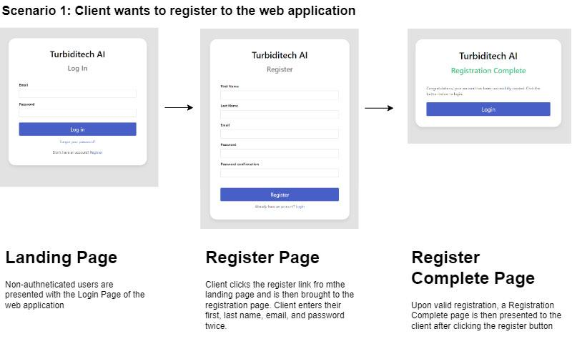

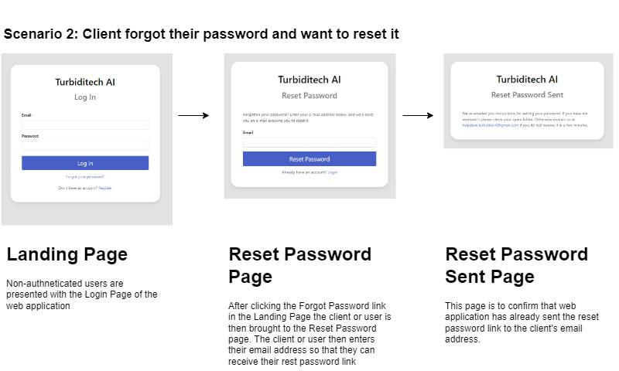

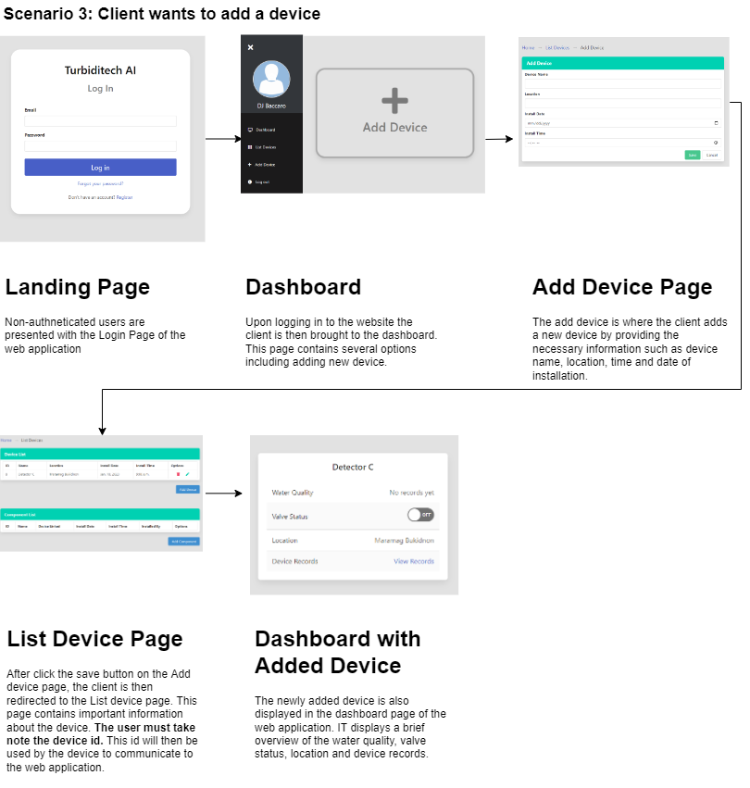



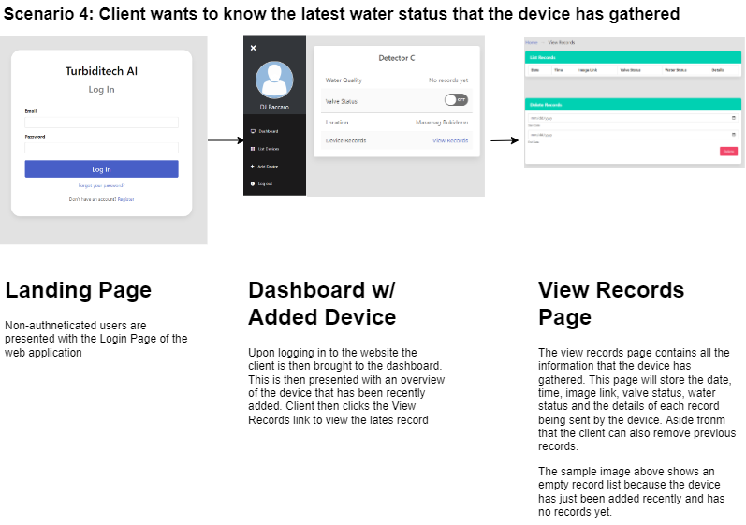

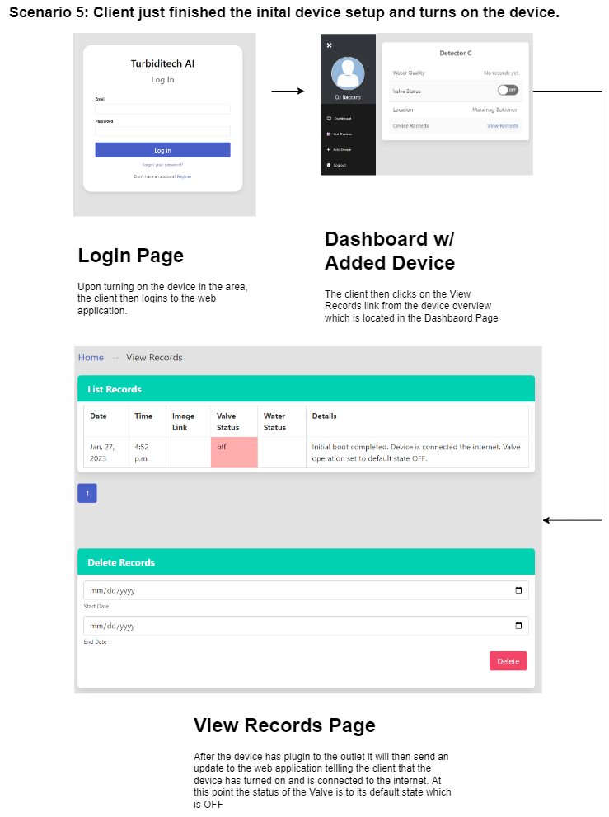

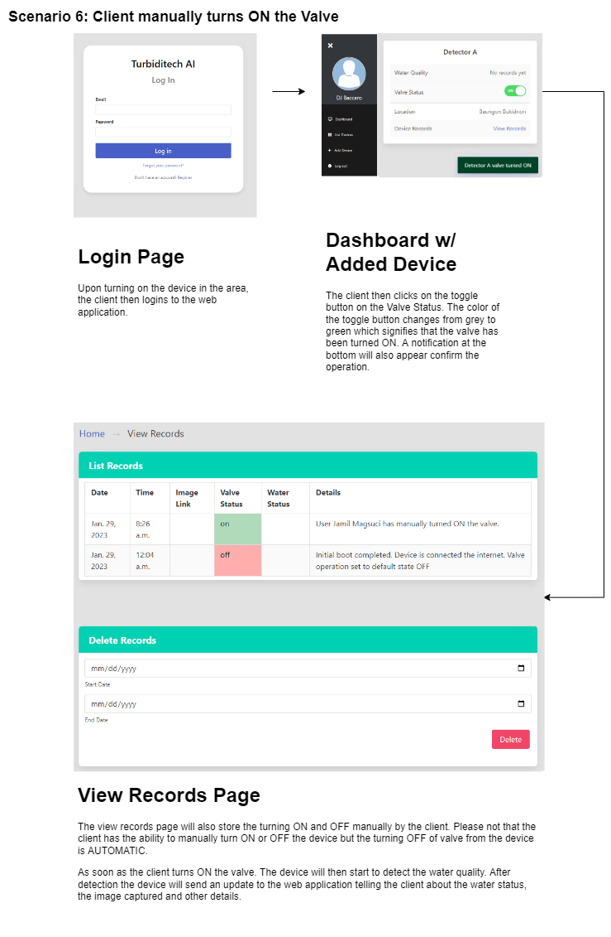

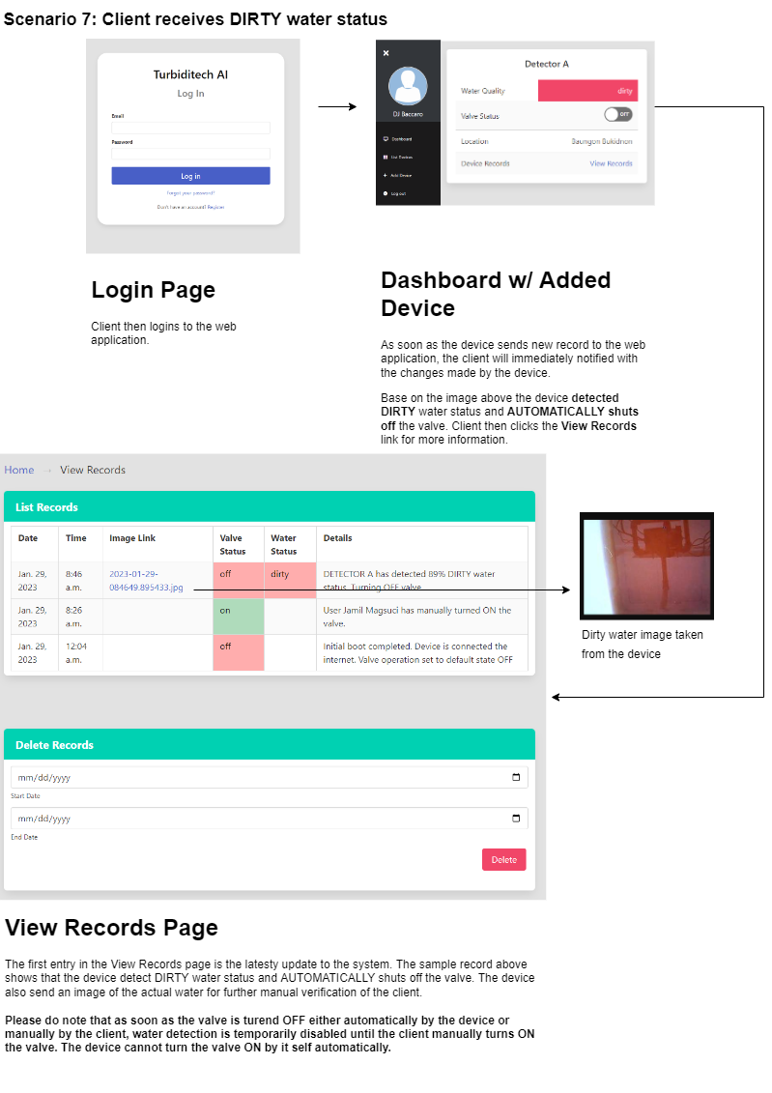

**4.2 Performance Testing Procedure for ML Module**

In this study, we developed a machine learning model using Teachable Machine to predict water turbidity for both clean and dirty water samples. The datasets consisted of 4,994 clean water samples and 10,793 dirty water samples, which were split into training and testing sets using an 80/20 ratio. The data was labeled as either "clean" or "dirty" and imported into Teachable Machine.

After training the model, we evaluated its performance on the testing data separately for clean and dirty water samples. Assuming that the model made the following predictions.

**For clean water samples:**

1,100 samples correctly classified as clean (True Positive or TP)

502 samples misclassified as dirty (False Negative or FN)

**For dirty water samples:**

9,670 samples correctly classified as dirty (True Negative or TN)

121 samples misclassified as clean (False Positive or FP)

Using these predicted values, we can calculate the precision and recall metrics separately for clean and dirty water samples.

**For clean water samples, the precision and recall values are:**

Precision = TP / (TP + FP) = 1,100 / (1,100 + 121) = 0.901

Recall = TP / (TP + FN) = 1,100 / (1,100 + 502) = 0.686

This indicates that the model accurately predicts clean water samples in 90.1% of the cases, but only 68.6% of the actual clean water samples are correctly identified by the model.

**For dirty water samples, the precision and recall values are:**

Precision = TN / (TN + FP) = 9,670 / (9,670 + 502) = 0.950

Recall = TN / (TN + FN) = 9,670 / (9,670 + 121) = 0.988

This indicates that the model accurately predicts dirty water samples in 95.0% of the cases, and 98.8% of the actual dirty water samples are correctly identified by the model.

**4.3 System Testing Procedure and evaluation Results**

Table 5 presents the results of hands-on testing of the Baungon Water Supply system office, conducted by the administrator and observed by other respondents. The system was evaluated for its intuitiveness and ease of use, the clarity and usefulness of error messages, the ability to detect dirty water and automatically shut off the valve, and the capability to be manually controlled through a web application. After the testing, the respondents completed a questionnaire based on the ISO 9126 model, adapted by the proponents, to provide additional feedback on the system.

Table 5. Testing Results

|  |  |  |  |  |
| --- | --- | --- | --- | --- |
| **Test Case** | **Steps** | **Expected result** | **Actual Result** | **Pass/Fail** |
| Verify User Interface is Intuitive and Easy to Use | 1. Log in to the web application as a user.  2. Navigate through the different sections of the web application.  3. Attempt to perform common tasks such as opening and closing the valve. | The user interface should be easy to understand and use, with clear labels and instructions. | The user interface was easy to understand and use, with clear labels and instructions. | **Pass** |
| Verify System Provides Clear and Useful Error Messages | 1. Attempt to perform an invalid task on the web application.  2. Observe the error message displayed by the system | The error message should be clear and provide information on how to correct the issue. | The error message was clear and provided information on how to correct the issue. | **Pass** |
| Verify that the system can detect dirty water and shut off the valve automatically | 1. Turn on the valve manually to begin the test.  2. Introduce a known quantity of a substance (such as dirt or sediment) into the water to simulate dirty water conditions.  3. Confirm that the sensor detects the dirty water and sends a signal to automatically shut off the valve. | The camera sensor should detect dirty water and shut off the valve automatically | The camera sensor detected dirty water and shut off the valve automatically. | **Pass** |
| Verify that the system can be manually controlled through the web application | 1. Log in to the web application as an admin.  2. Confirm that the valve can be manually opened and closed using the controls on the web application.  3. Verify that the valve has been opened or closed by checking the flow of water. | The valve should be able to be manually opened and closed using the web application. | The valve was able to manually opened and closed using the web application | **Pass** |

**4.4 Survey Results**

Ten respondents were selected for the study, including one office head, two plumbers, one clerk, three water treatment plant in charge, two pipeline maintenance personnel, and one engineer from the office of the municipal office head. The selection was based on the requirement that the device should be tested by those who would be using it. The results of the user test were then recorded in Table 6.

Table 6. User’s Response (Summary)

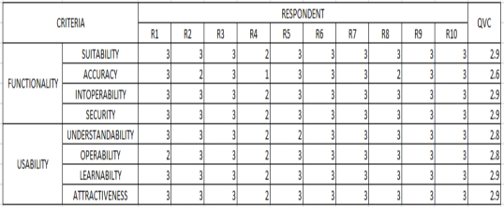

Based on Table 7, the project was rated as Excellent with a quality factor of 0.95 (please refer to chapter 3 to see how the data was computed). This means that it has satisfactorily met the specific requirements and intended functions.

Table 7 Statistical Treatment of Data Result

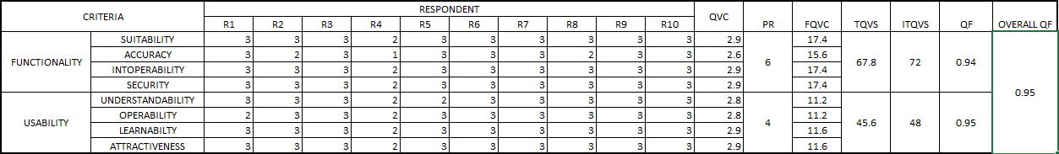

**CHAPTER V**

**SUMMARY, CONCLUSIONS, AND RECOMMENDATIONS**

This chapter covers the summary of findings, conclusions and recommendations of the study. This includes the summary of the results obtained, the answer for the problems that needed to be solved and to the treatment of the limitations needed to be improved through the use of recommendations. This chapter tells the essential part of the research and project design process. This chapter answers the objectives of the study which serves as proof in the accomplishment and success of the project study. Lastly, it also includes recommendations for further improvement and development of the device.

**5.1 Summary of Findings**

1. The Smart Turbidity Detection System with automated valve shut-off" is a device that can detect turbidity in water using a teachable machine, and automatically shut off the valve upon detection of turbid water. Additionally, it has the capability of sending data to a web server for further manual analysis and monitoring.
2. The proponents utilized the ISO 9126 framework to evaluate the system's functionality, accuracy, and overall usability. The device's testing and results reveal that Smart Turbidity Detection System with automated valve shut-off functionality were met.

**5.2 Conclusions**

The study indicates that implementing the Smart Turbidity Detection System with an automated valve shut-off can effectively reduce or eliminate turbid water from entering the Baungon water supply, eliminating the need for manual intervention by Baungon Water Works personnel. This will guarantee a high-quality water supply for all consumers.

* The water quality monitoring problem at Baungon, managed by the Baungon Water Supply System, is as follows: The source of water for Baungon is a waterfall, and during rainy periods, the water becomes turbid. To prevent the turbid water from entering the supply for Baungon residents, the valves are shut off. The issue with manual monitoring of water quality regularly is that it requires constant presence and can cause problems in emergency situations or unexpected rain. After the rain stops and the water is clean, the valves are opened, but this process may be delayed due to the remote location of the site, which is only accessible by hiking.
* The Smart Turbidity Detection System with automated valve shut-off was designed to address the water quality monitoring issue at Baungon Water Supply, managed by the Baungon Water Supply System. It uses Raspberry Pi and a machine-learning model, with a Pi camera, for detection. The system also has the ability to send data to an application server for monitoring and analysis. With this system in place, the water monitoring process will become automated, eliminating the need for manual monitoring. The system offers a reliable, efficient, and cost-effective solution for water quality monitoring, ensuring a constant supply of safe and clean water for consumers.

The Smart Turbidity Detection System gained a resulting quality factor of 0.92 on ISO 9126. Based on the results, the system passed the said standard quality evaluation.

**5.3 Recommendations**

Based on the results of the study, and to further improve the system the researcher recommends upgrading to high-end components, such as open-source single-board computers and a camera sensor with a more rigid and robust enclosure that is also water resistant. The accuracy of the machine learning model largely depends on the data being fed to the model. It is recommended to take sample data from different time periods in order to accommodate the different light conditions that may significantly affect the recognizing ability of the machine learning model. The researcher also recommends including additional sensors like turbidity sensor and photodiode sensor that could help increase the accuracy of the results. Moreover, the researcher recommends placing the system in a well-lit environment for effective operation during the night. In terms of internet connectivity it is highly recommended to use wifi or ethernet connection connected to a 3g or 4g network for stable transfer of data.

**BIBLIOGRAPHY**

Alpaydin, E. (2014).*Introduction to machine learning*. 3rd ed. Cambridge, MA: The MIT Press; 2014.

Ayodele, T. O. (2010). Types of machine learning algorithms. New advances in machine learning, 3, 19-48.

Borkowski, A. A., Wilson, C. P., Borkowski, S. A., Thomas, L. B., Deland, L. A., Grewe, S. J., & Mastorides, S. M. (2019). Google Auto ML versus Apple Create ML for Histopathologic Cancer Diagnosis; Which Algorithms Are Better?. *arXiv preprint arXiv:1903.08057.*

Boyd, C. E. (2019). *Water quality: an introduction*. Springer Nature

Cloud AutoML Custom Machine Learning Models | Google Cloud. (2022). Retrieved 16 April 2022, from <https://cloud.google.com/automl>

D. Agustian, P. P. G. P. Pertama, P. N. Crisnapati and P. D. Novayanti, "Implementation of Machine Learning Using Google's Teachable Machine Based on Android," 2021 3rd International Conference on Cybernetics and Intelligent System (ICORIS), Makasar, Indonesia, 2021, pp. 1-7, doi: 10.1109/ICORIS52787.2021.9649528.

Daigavane, V. V., & Gaikwad, M. A. (2017). Water quality monitoring system based on IoT. Advances in wireless and mobile communications, 10(5), 1107-1116.

Design and Development of a Portable Turbidity Meter" (2016), published in the Journal of Engineering and Technology by proponents at the University of Santo Tomas.

"Development of a Low-Cost Turbidity Sensor Using a Photodiode and an LED" (2014), published in the Philippine Journal of Science by proponents at the University of the Philippines Diliman.

Dinka, M. O. (2018). Safe drinking water: concepts, benefits, principles and standards. *Water challenges of an urbanizing world, intechopen, London*, 163-181.

El Naqa, I., & Murphy, M. J. (2015). What is machine learning?. In machine learning in radiation oncology (pp. 3-11). Springer, Cham.

Forchhammer, S., Abu-Ghazaleh, A., Metzler, G., Garbe, C., & Eigentler, T. (2022). Development of an Image Analysis-Based Prognosis Score Using Google’s Teachable Machine in Melanoma. Cancers, 14(9), 2243.

Hafeez, S., Wong, M. S., Ho, H. C., Nazeer, M., Nichol, J., Abbas, S. & Pun, L. (2019). Comparison of machine learning algorithms for retrieval of water quality indicators in case-II waters: A case study of Hong Kong. Remote sensing, 11(6), 617.

Hinton, GE (2007). Learning multiple layers of representation. *Trends Cogn Sci. 2007;11:428–34.*

Ifrah, G. (2001). *The universal history of computing: from the abacus to the quantum computer.*New York: John Wiley; 2001.

Info@lawtomated.com. (2020, February 2). A.I. Technical - machine learning vs. Deep Learning. lawtomated. Retrieved June 26, 2022, from <https://lawtomated.com/a-i-technical-machine-vs-deep-learning/>

Kruse, Peter. "Review on water quality sensors." *Journal of Physics D: Applied Physics* 51.20 (2018): 203002.

Lambrou, T. P., Anastasiou, C. C., & Panayiotou, C. G. (2009, September). A nephelometric turbidity system for monitoring residential drinking water quality. *In International Conference on Sensor Applications, Experimentation and Logistics* (pp. 43-55). Springer, Berlin, Heidelberg.

Mitchell, T. (1997). *Machine learning*. New York: McGraw-Hill; 1997

Perlato, A. (n.d.). The learning rate. The Learning Rate - Andrea Perlato. Retrieved June 26, 2022, from https://www.andreaperlato.com/theorypost/the-learning-rate/

S. B. (2022, January 5). Ai vs machine learning vs deep learning. Edureka. Retrieved June 26, 2022, from <https://www.edureka.co/blog/ai-vs-machine-learning-vs-deep-learning/>

Samuel, A. (1959). Some studies in machine learning using the game of checkers. *IBM: J Res Dev.1959;3:210–29*.

Thompson, T., M. Sobsey, and J. Bartram. "Providing clean water, keeping water clean: an integrated approach." *International Journal of Environmental Health Research* 13.sup1 (2003): S89-S94.

Wang, Y., Chen, J., Cai, H., Yu, Q., & Zhou, Z. (2021). Predicting water turbidity in a macro-tidal coastal bay using machine learning approaches. Estuarine, Coastal and Shelf Science, 252, 107276.

Zeng, Y., & Zhang, J. (2020). A machine learning model for detecting invasive ductal carcinoma with Google Cloud AutoML Vision. Computers in Biology and Medicine, 122, 103861.

**Appendix A**

Listed below is the source code for activate_gprs.sh located inside the device

#!/bin/bash

# Initialize the variable to store the IP address

ip_address=""

# Run the loop until the IP address is not empty

while [ -z "$ip_address" ];

do

# Get the IP address

ip_address=$(ip address | grep ppp0 | awk '/inet/ {print $2}')

# If the IP address is empty, print a message and continue the loop

if [ -z "$ip_address" ]; then

echo $(date -u) "Unable to retrieve the IP address." | tee -a log.txt

sleep 5

echo $(date -u) "Closing previous PPP connection." | tee -a log.txt

sudo poff rnet > /dev/null

sleep 5

sudo kill -HUP 'cat /var/run/ppp0.pid'

sleep 5

sudo route del default

sleep 5

echo $(date -u) "Starting new PPP connection." | tee -a log.txt

sudo pon rnet

sleep 5

fi

done

echo $(date -u) "The IP address is $ip_address" | tee -a log.txt

**Appendix B**

Listed below is the source code for activate_script.sh located inside the device

#!/bin/bash

# Change directory

cd /home/turbiditech/turbiditech-rpi/raspberry_pi/

echo $(date -u) "Change directory" | tee -a log.txt

echo $(date -u) "Activate VENV" | tee -a log.txt

source venv/bin/activate

echo $(date -u) "Start detection loop." | tee -a log.txt

echo "" | tee -a log.txt

python main.py

**Appendix C**

Listed below is the source code for main.py script inside the device

# rpi

import numpy as np

from time import sleep

from PIL import Image

from tflite_runtime.interpreter import Interpreter

from picamera import PiCamera

from gpiozero import DigitalOutputDevice

# api

import requests

import os

import http.client

import mimetypes

import urllib.parse

import binascii

from codecs import encode

from base64 import b64encode

from dotenv import load_dotenv

# constants

load_dotenv()

DEVICE_ID = os.getenv('DEVICE_ID')

DEVICE_NAME = os.getenv('DEVICE_NAME')

EMAIL = os.getenv('EMAIL')

PASSWORD = os.getenv('PASSWORD')

# obtaining data

def capture_image():

# capture image using PiCamera

with PiCamera() as camera:

camera.resolution = (300, 300)

camera.zoom = (0.3, 0.3, 1.0, 1.0)

# warm up camera

sleep(3)

# adjusting the blue tint on low light env

# camera.awb_mode = 'auto'

camera.drc_strength = 'high'

camera.image_effect = 'denoise'

# preview and capture image

# camera.start_preview()

sleep(3)

camera.capture('../images/test.jpg', quality=100)

# compress image for upload

im = Image.open("../images/test.jpg")

# Set the quality to 50 (out of 100)

im.save("../images/test_compressed.jpg", quality=50, optimize=True)

def read_image(w, h):

image_path='../images/test.jpg'

img = Image.open(image_path).convert('RGB')

# crop image to center

# frac = 0.70

# left = img.size[0] * ((1-frac)/2)

# upper = img.size[1] * ((1-frac)/2)

# right = img.size[0] - ((1-frac)/2) * img.size[0]

# bottom = img.size[1] - ((1-frac)/2) * img.size[1]

# img = img.crop((left, upper, right, bottom))

img = img.resize((224, 224))

# show image

# img.show()

return img

# process data

def load_labels(path):

with open(path, 'r') as f:

return [line.strip() for i, line in enumerate(f.readlines())]

def set_input_tensor(interpreter, image):

# locate the first tensor index from input details

tensor_index = interpreter.get_input_details()[0]['index']

# return input tensor base on its index

input_tensor = interpreter.tensor(tensor_index)()[0]

# passing image data to input tensor

input_tensor[:, :] = image

def unset_input_tensor(interpreter):

tensor_index = interpreter.get_input_details()[0]['index']

input_tensor = interpreter.tensor(tensor_index)()[0]

# reset input tensors to prevent using same image

input_tensor[:, :] = np.zeros(shape=(224, 224, 3))

def classify_image(interpreter, image):

# models makes a prediction and store to output tensor

interpreter.invoke()

output_details = interpreter.get_output_details()[0]

# predicted class label score

scores = interpreter.get_tensor(output_details['index'])[0]

# dequantized the scores

scale, zero_point = output_details['quantization']

scores_dequantized = scale * (scores - zero_point)

#predicted class label probability

dequantized_max_score = np.max(np.unique(scores_dequantized))

# predicted class label id

max_score_index = np.where(scores_dequantized == np.max(np.unique(scores_dequantized)))[0][0]

return max_score_index, dequantized_max_score

def check_water(retry=3, delay=5):

label_path = '../model/labels.txt'

model_path = '../model/model.tflite'

# set labels

labels = load_labels(label_path)

# alternative : from tflite_runtime.interpreter import Interpreter

# interpreter = tf.lite.Interpreter(model_path)

interpreter = Interpreter(model_path)

# print('model loaded successfully')

# allocate to memory

interpreter.allocate_tensors()

# get input details

_, height, width, _ = interpreter.get_input_details()[0]['shape']

# start loop

while True:

result = []

temp = []

for i in range(retry):

# capture image using PiCamera

capture_image()

# read and resize to np array image

image = read_image(width, height)

# initialize data to feed to model

set_input_tensor(interpreter, image)

# make predictions

label_id, prob = classify_image(interpreter, image)

# getting results

class_label = labels[label_id].split()[-1]

accuracy = np.round(prob * 100, 2)

# collect resutls

temp.append((class_label, accuracy))

# reset input tensor

unset_input_tensor(interpreter)

sleep(delay)

# check for consitent results

result = np.unique(list(map(lambda x: x[0], temp))).tolist()

if len(result) == 1:

avg_accu = np.round(np.mean(list(map(lambda x: x[-1], temp))), 2)

return result[0], avg_accu

else:

print(temp)

print('invalid results, check again.')

# send / receive data from API

def get_server_status():

url = f'https://turbiditech.fly.dev/api/device-records/{DEVICE_ID}'

r = requests.get(url, auth=(EMAIL, PASSWORD))

if r.status_code == 200:

data = r.json()[-1]

v_stat = data['valve_status']

w_stat = data['water_status']

return v_stat, w_stat

else:

return r.status_code

def get_device_water_status():

# device water status

res, prob = check_water(retry=2)

w_stat = res

return w_stat, prob

def post_water_valve_status(w_stat, v_stat, prob):

url = urllib.parse.urlsplit(f'https://turbiditech.fly.dev/api/device-records/{DEVICE_ID}')

image_path = '../images/test_compressed.jpg'

details = f'{DEVICE_NAME.upper()} has detected {prob}% {w_stat.upper()} water status. Turning {v_stat.upper()} valve.'

conn = http.client.HTTPSConnection(url.hostname)

dataList = []

boundary = boundary = binascii.hexlify(os.urandom(16)).decode('ascii')

dataList.append(encode('--' + boundary))

dataList.append(encode('Content-Disposition: form-data; name=valve_status;'))

dataList.append(encode('Content-Type: {}'.format('text/plain')))

dataList.append(encode(''))

dataList.append(encode(f'{v_stat}'))

dataList.append(encode('--' + boundary))

dataList.append(encode('Content-Disposition: form-data; name=water_status;'))

dataList.append(encode('Content-Type: {}'.format('text/plain')))

dataList.append(encode(''))

dataList.append(encode(f'{w_stat}'))

dataList.append(encode('--' + boundary))

dataList.append(encode('Content-Disposition: form-data; name=record_device;'))

dataList.append(encode('Content-Type: {}'.format('text/plain')))

dataList.append(encode(''))

dataList.append(encode(f'{DEVICE_ID}'))

dataList.append(encode('--' + boundary))

dataList.append(encode('Content-Disposition: form-data; name=details;'))

dataList.append(encode('Content-Type: {}'.format('text/plain')))

dataList.append(encode(''))

dataList.append(encode(f'{details}'))

dataList.append(encode('--' + boundary))

dataList.append(encode('Content-Disposition: form-data; name=record_image; filename={0}'.format(image_path)))

fileType = mimetypes.guess_type(image_path)[0] or 'application/octet-stream'

dataList.append(encode('Content-Type: {}'.format(fileType)))

dataList.append(encode(''))

with open(image_path, 'rb') as f:

dataList.append(f.read())

dataList.append(encode('--'+boundary+'--'))

dataList.append(encode(''))

body = b'\r\n'.join(dataList)

payload = body

headers = {

'Authorization': f'Basic {b64encode(bytes(f"{EMAIL}:{PASSWORD}", "utf-8")).decode("ISO-8859-1")}',

'Content-type': f'multipart/form-data; boundary={boundary}'

}

conn.request("POST", "/api/device-records/2", payload, headers)

res = conn.getresponse()

# data = res.read()

print(res.status, res.reason)

if res.status == 200:

print('success sending data.')

else:

print('error sending data.')

def main():

# Create instance for the specified pin

valve = DigitalOutputDevice(18)

while True:

# check server for changes in the valve status

print('getting data from server')

server_v_stat, server_w_status = get_server_status()

print(f'valve status manually turned {server_v_stat.upper()}')

# if both server and device valve is OFF

if (server_v_stat == 'off') and (valve.value == 0):

valve.off()

print('both server and device valve status are turned OFF')

# if server valve is OFF and device valve is ON

if (server_v_stat == 'off') and (valve.value == 1):

print('user manually turned OFF the valve')

print('turn valve OFF')

valve.off()

# if the valve has been turned on

# then turn on valve base on check water status results

if server_v_stat == 'on':

print('checking water status first')

device_w_stat, prob = get_device_water_status()

print(f'device has detected {prob}% {device_w_stat.upper()} water status.')

if (server_w_status == 'clean') and (device_w_stat == 'clean'):

valve.on()

print(f'both server and device water status are CLEAN')

else:

if device_w_stat == 'clean':

print('turn valve ON')

valve.on()

v_stat = 'on'

else:

print('turn valve OFF')

valve.off()

v_stat = 'off'

print('sending results to server')

post_water_valve_status(w_stat=device_w_stat, v_stat=v_stat, prob=prob)

print('sleep 10 seconds.\n\n')

sleep(10)

if __name__ == "__main__":

main()

**Appendix D**

Listed below is the timeline of activities from concept paper presentation up to final presentation

